
Dhruvil Dobariya
dhruvildobariya21@gmail.com
Abstract
In this module I learn about how to operate DMS.
DMS
Documentation

Index
1 Introduction to DMS 1
1.1 What is DMS 1
1.2 User of DMS 1
1.3 Flow of DMS 1
2 Dashboard(Superamdin) 3
2.1 Introduction 3
3 Master(Superadmin) 6
3.1 Introduction 6
3.2 Dealer Master 6
3.3 GST Master 8
3.4 Comments Master 10
3.5 Product Master 10
4 Import Party(Superadmin) 15
4.1 Introduction 15
5 Manage Rate(Superadmin) 16
5.1 Introduction 16
5.2 Region wise rate 16
5.3 Dealer wise rate 16
5.4 Assign Rate/Product 17
5.5 Price Category 18
6 Geographical(Superadmin) 19
6.1 Introduction 19
7 Utility(Superadmin) 20
7.1 Introduction 20
7.2 Manage Salesman 20
7.3 Assign Route 21
7.4 Dealer Notice 21
7.5 Bill Price Edit 22
7.6 Manage Team 23
7.7 Change Party Name 23
7.8 Manage Party 24
7.9 Manage Route 24
7.10 Manage Pricelist File 25
7.11 Manage Dashboard Image 26
7.12 Reset Password 26
7.13 Edit Company 27
8 Report(Superadmin) 29

8.1 Introduction 29
8.2 Sales Report 29
8.3 Purchase Report 36
8.4 Summary Report 37
8.5 Stock Report 41
8.6 Analysis Report 44
8.7 Other Report 49
9 Setup(Superadmin) 51
9.1 Introduction 51
9.2 User Security 51
9.3 Company Setup 52
9.4 Voucher Setup(Pending) 55
10 Master(Dealer) 56
10.1 Introduction 56
10.2 Product Master 56
10.3 Salesman Master 56
10.4 Route Master 57
10.5 Party Master 58
10.6 Sync Mobile(Pending) 59
10.7 Transport 60
10.8 Change Party Name 60
10.9 Vehicle 61
11 Purchas(Dealer) 62
11.1 Introduction 62
11.2 Add Purchase Bill 62
11.3 Purchase Bill 62
11.4 Purchase Return 63
12 Sales(Dealer) 64
12.1 Introduction 64
12.2 Add Sales Order 64
12.3 Sales Order 64
12.4 Add Sales Invoice 65
12.5 Sales Invoice 66
12.6 Sales Return 70
12.7 E-Invoice 70
13 Physical Voucher(Dealer) 72
13.1 Introduction 72
14 Godown Stock(Dealer) 73
14.1 Introduction 73

15 Report(Dealer) 74
15.1 Introduction 74
16 Application Setup 76
16.1 Introduction 76

Introduction to DMS

What is DMS
- DMS is web application which helps to company and dealer to manage their products and other delivery related activity.
- DMS stated for Dealer Management System.

User of DMS
- DMS have three types of Users.
  - Superadmin
  - Dealer
  - Salesman
Superadmin:
- Dealer Management
- Help dealer to distribute product to retailer
- Retails sales analysis
Dealer:
- Order products form company
- Distributes purchased products to retailer with help of salesman
- Sales analysis
Salesman:
- Visit retail’s shop and punch sale order

Flow of DMS
- We have appropriate flow to supply product from company to customer.
Superadmin:
- Create Dealer
- Create Product
- Product and rate setup
- Assign product to dealer
Dealer:
- Purchase products
- Create Routes
- Create Party
- Appoint Salesman
- Assign Routes to Salesman
Salesman:
- Get Registration
- Visit Retail Shop
- Punch sales orders

Dashboard(Superamdin)

Introduction
- Dashboard divide into two parts.
  - Charts
  - Reports
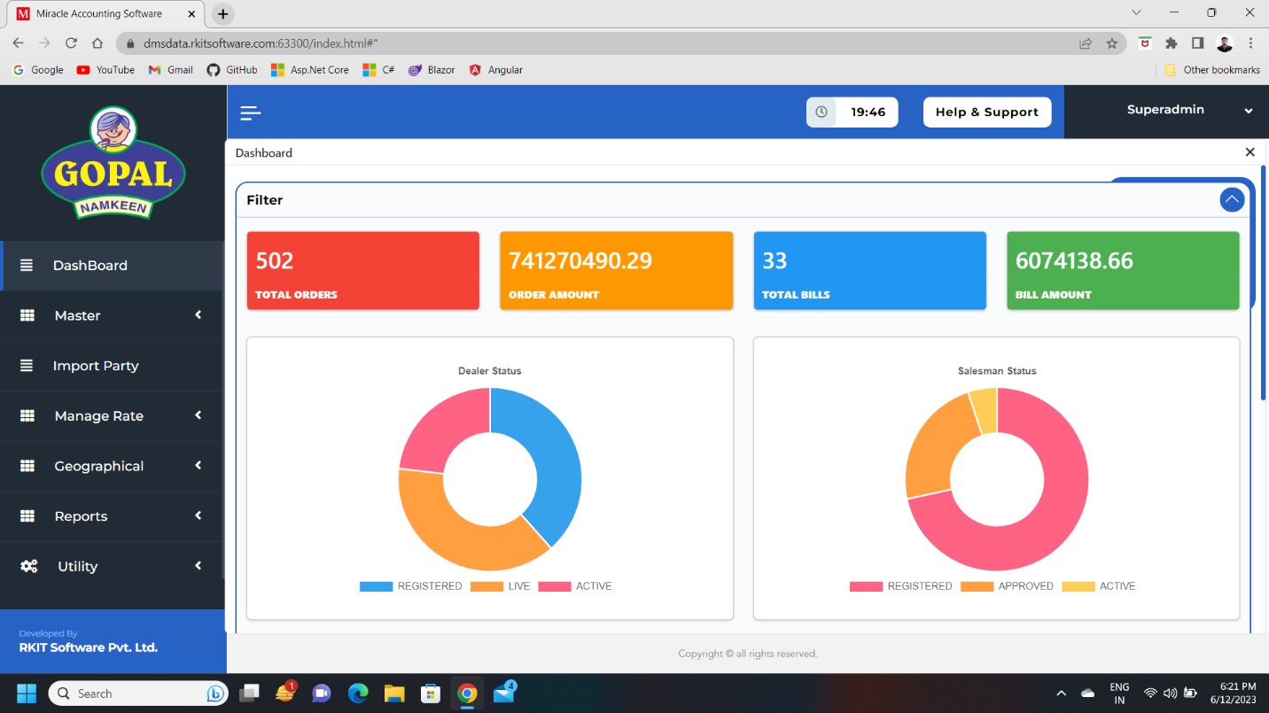
Charts:

- In chart part first we have 4 counters
  - Total order
  - Order amount
  - Total bill
  - Bill amount
- All counter show details of a day, every day it’s update.
- Another component is we have 2 chart which is,
  - Dealer status
    - Registered:
      - How many dealers we have.
    - Live:
      - How many dealers have rights of livestock, if live stock is enable in dealer the dealer doesn’t billing in negative stock.
    - Active:
      - How many dealers take order in today.
  - Salesman status
    - Registered:
      - How many salesmen registered.
    - Approved:
      - How many salesmen approved for work by dealer.
    - Active:
      - How many salesmen punch order today.
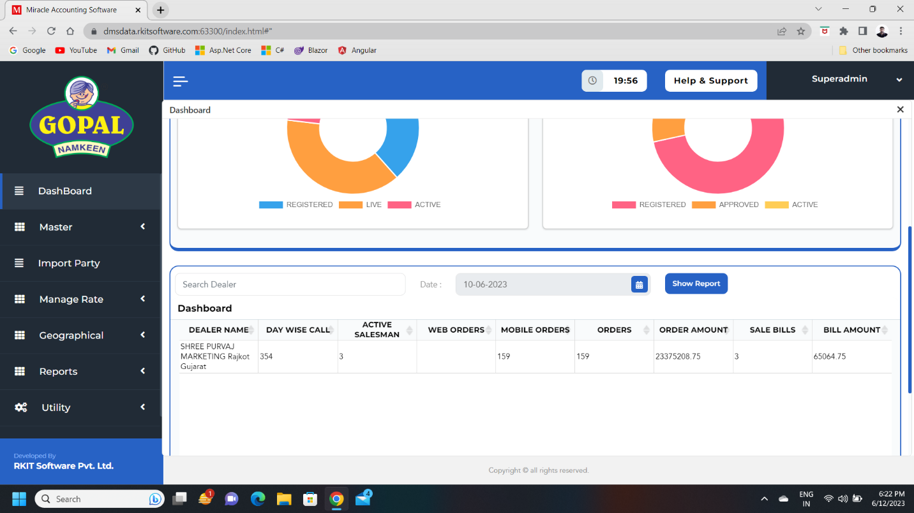
Reports:

- In this section we get one table, which container different types of information like,
  - Dealer name
  - Day wise call
  - Active salesman
  - Web order
  - Mobile order
  - Orders
  - Order Amount
  - Sale bill
  - Bill amount

Master(Superadmin)

Introduction
- In master we have 4 different components,
  - Dealer
  - Product
  - GST
  - Comment

Dealer Master
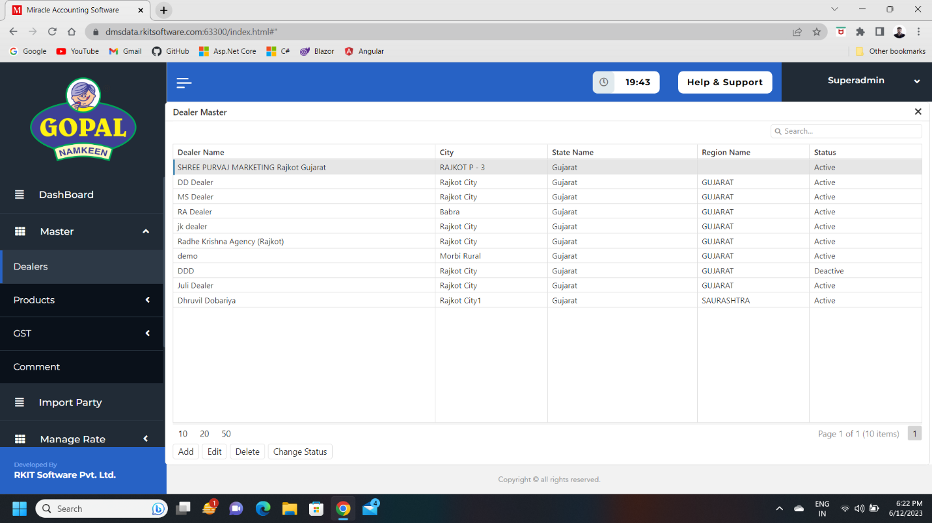
- In this component we can manage different dealers.

- In add or edit dealer, we have various field which contains information about dealer,
- But we have some field which we must know, because it’s new for us like,
  - Registration Type
    - Regular
      - Which have GST number and have turnover more than 50 lakh.
      - If we select Regular then we must give GST number.
    - Consumer
      - Customer which uses product
    - Unregistered
      - Retailer which has don’t registered for GST and have turnover less the 50 lakh.
    - Composition
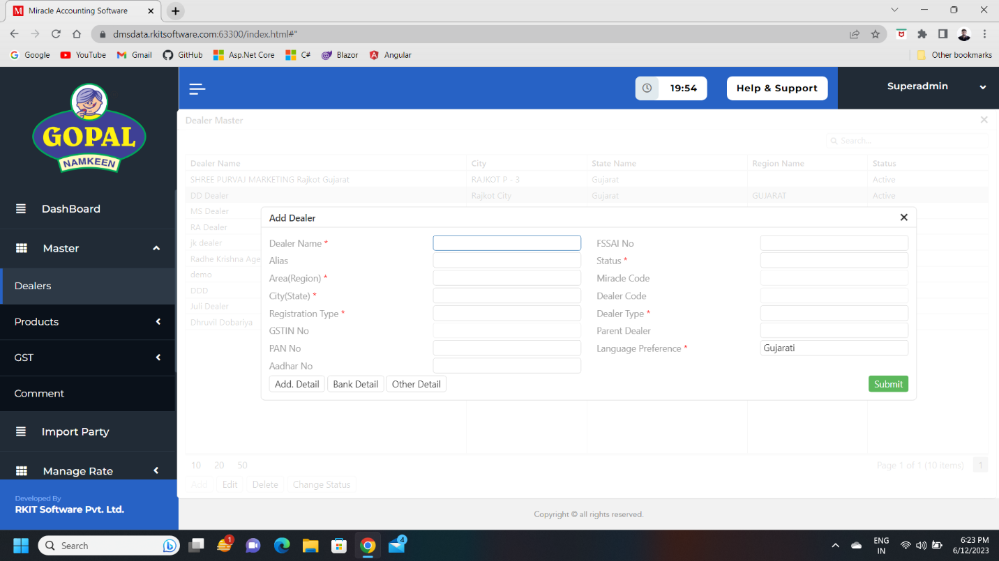
      - It like regular, but don’t follow GST slab and pay GST every one year as per Government rules and have turnover less than 50 lakh.

  - Dealer Type:
    - Regular
      - Its regular dealer which has own agency.
    - Outlet
      - It is branch of company which is directly sell products to customers.
  - Parent Dealer:
    - It selects if dealer is sub dealer of any agency.
  - Miracle Code:
    - It is automatically generated which is used to map dealer to Miracle’s dealer.
  - Dealer Code:
    - It is automatically generated which is used when salesman registered in mobile app at that time, they specify dealer code so we can map dealer with salesmen.
- We can also add other details like,
  - Address detail
  - Bank detail
  - Other details

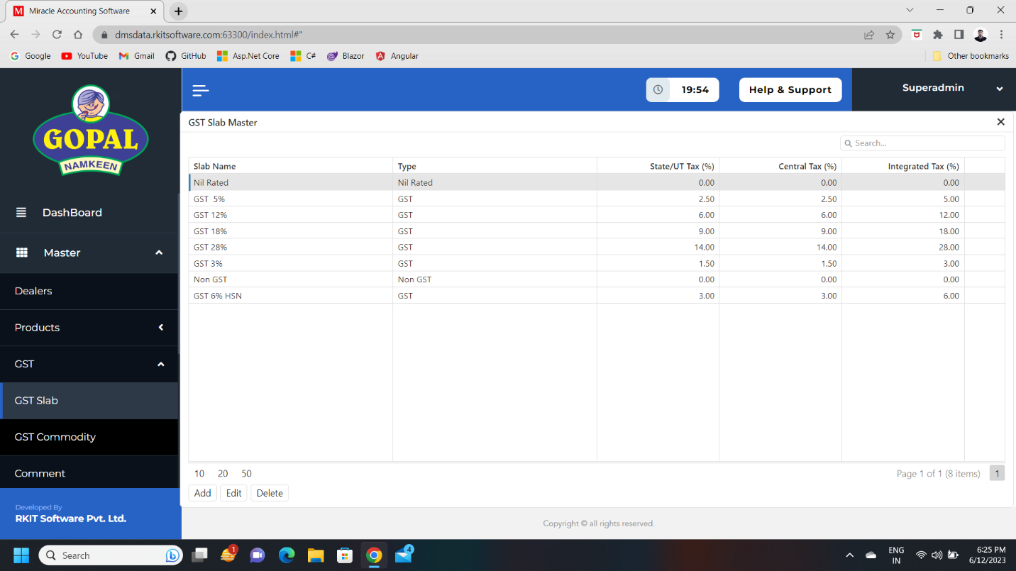
GST Master

- GST master contains two component which is,
  - GST Slab
    - In this component we can manage GST Slab.
  - GST Commodity
    - In this component we can manage GST Commodity.
    - It contains different details like,
      - Description
      - Commodity Type
        - Goods
        - Service
      - HSN/SAC Code
      - GST Slab
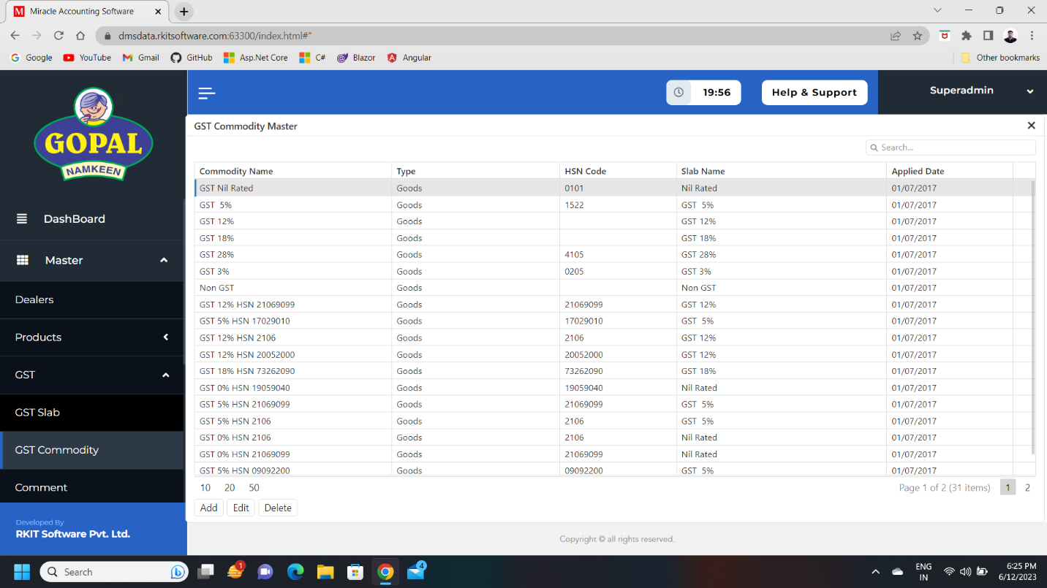
        - How much slab apply on which duration.
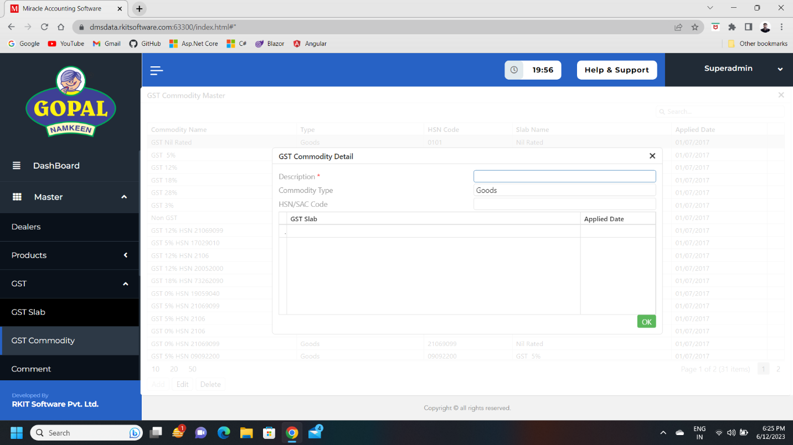

Comments Master
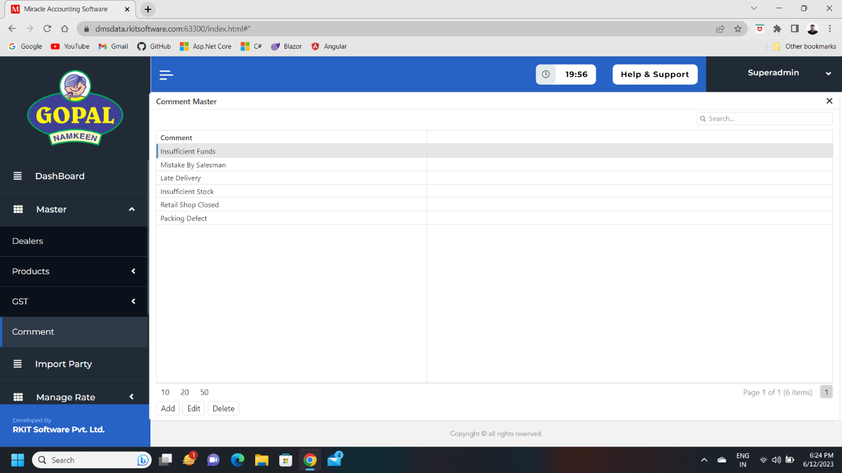
- This component used for save comments.

- These comments are used we some issues arrive during delivery life cycle of product, like,
  - Insufficient Funds
  - Mistake By Salesman
  - Late Delivery
  - Insufficient Stock
  - Retail Shop Closed
  - Packing Defect
- It used by salesman during punch order.

Product Master
- In this master we have 6 components,
  - Product
  - Product Group
  - Product Category
  - Product Sub Category
  - Sales Purchase Unit
  - Dealer Product
Sales Purchase Unit:
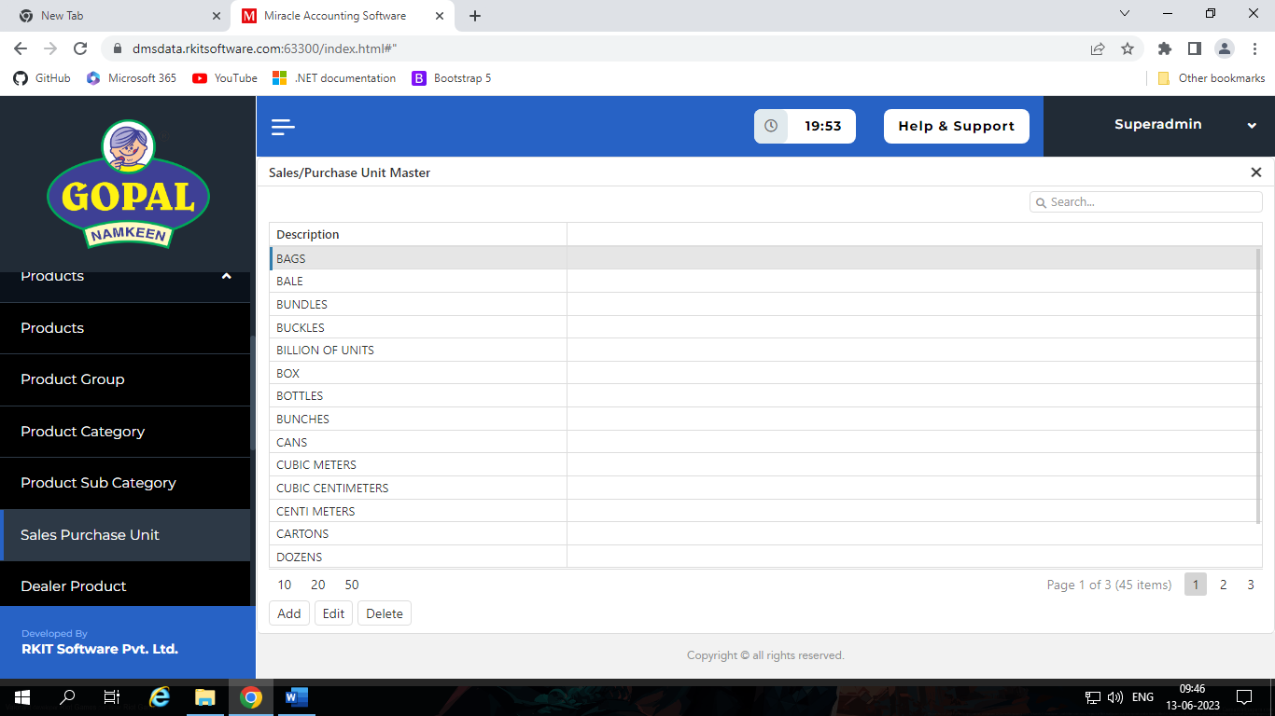
- This component contains different types of units which we use for sales and purchase product.

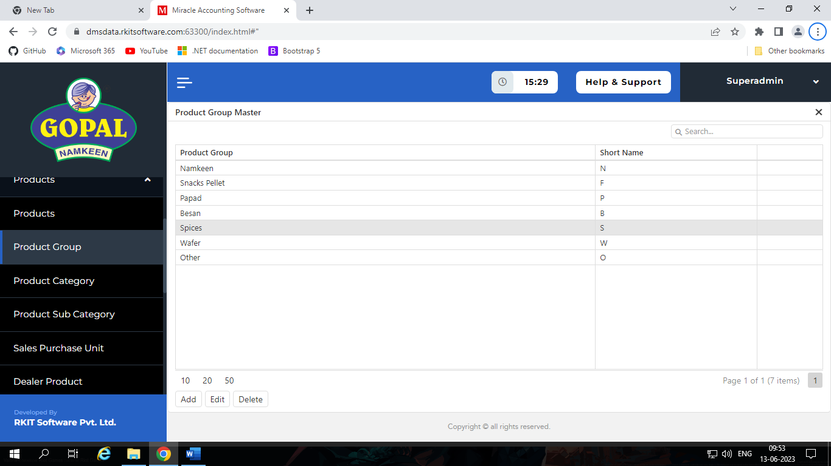
Product Group:
- This component contains details about type of product, it’s short names of type and sequence, like, Namkeen, Snacks Pellet, Papad, Besan, Spices, Wafer and Other.
Product Category:
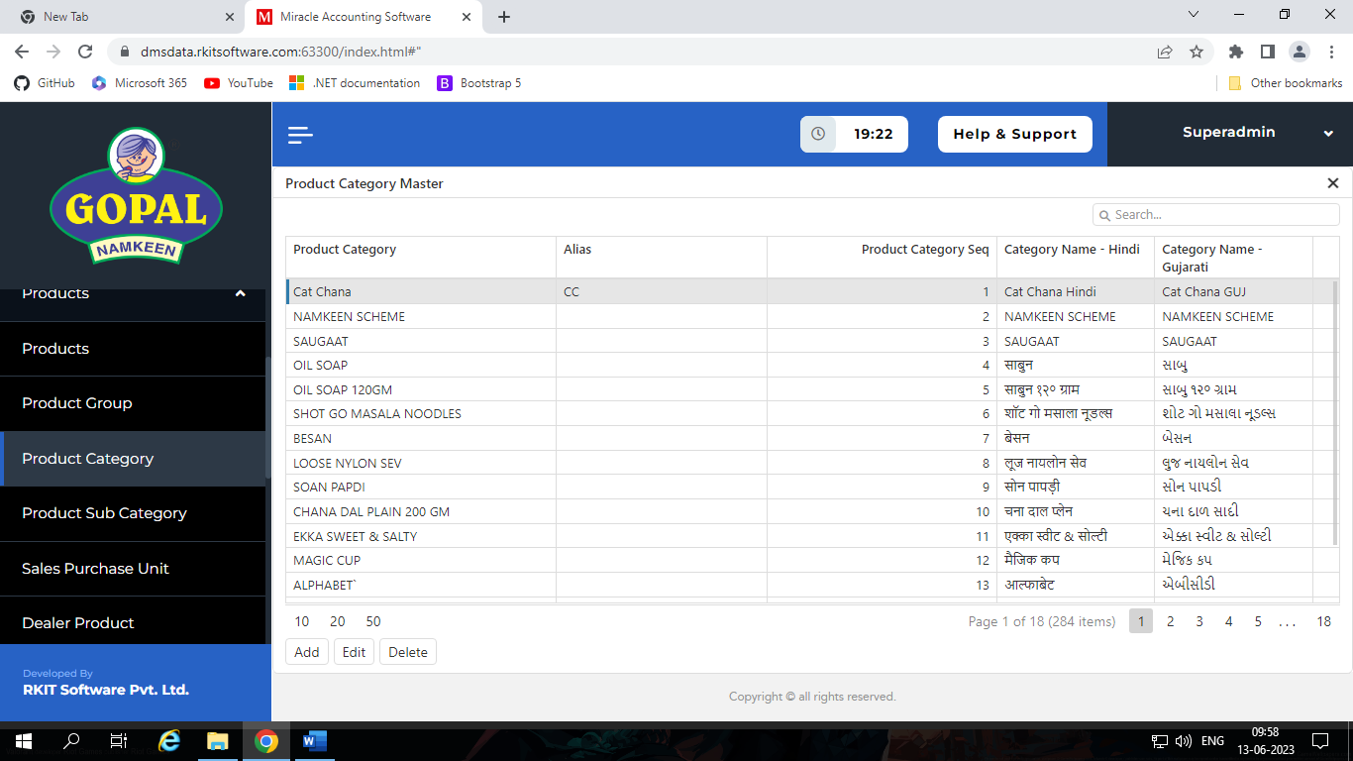
- It contains different type of category of product, in other word it is name of product like, Chana dal, Sev mamara, Kurkure…..

- In add-edit section we have different types of fields like,
  - Product Category Name
  - Alias
  - Sequence
  - Category Name – Gujarati
  - Category Name – Hindi
  - Product Group
  - Is Loose Product
    - It Yes, then dealer can sale this product as loose product
Product Sub Category:
- This section contains sub category of product like, 10 gram pack, 20 RS pack, 1KG pack…
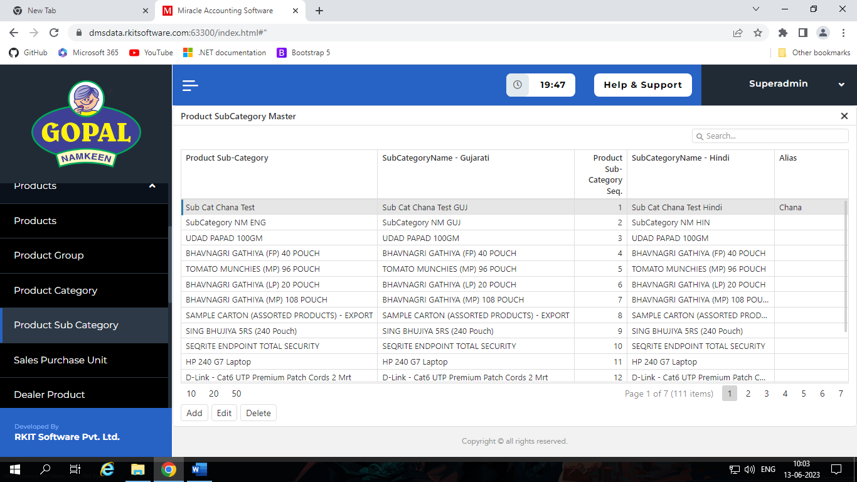
Product:
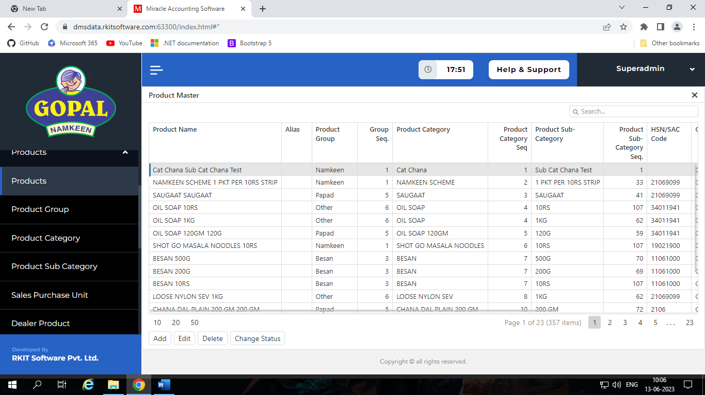
- This section contains details about product, like, Chana dal 10 RS, Chana dal 20 RS, Sev mamara 100 gram…
- In add-edit mode we have different type of field like,
  - Miracle Code
  - Product Name
    - It created by combination of Product Category and Product Sub Category
    - Ex: We select Product Category “Chana dal” and Product Sub Category “10 RS Pack”, Then Product Name should be “Chana dal 10 RS Pack”.
  - Status
    - Active / De - Active
  - Commodity
  - Purchase Rate
  - Sales Rate
  - Purchase Unit
  - Sales Unit
  - Conversation Factor
    - It uses to maintain stock of product like,
    - Ex: We have one Box of product which contains 10 strip and each strip contains 10 packs.
    - So, if dealer sales as box then conversion factor is 1, so stock = stock * 1
    - So, if dealer sales as strip then conversion factor is 10, so stock = stock * 10
    - So, if dealer sales as packs then conversion factor is 100, so stock = stock * 100
  - Allow half strip
    - If yes, the dealer can sale product in half strip.
  - Miracle Code:
    - It is used to map product with ERP system.
Dealer Product:
- In this section we can see details of dealer with their products which we are assign.

Import Party(Superadmin)

Introduction
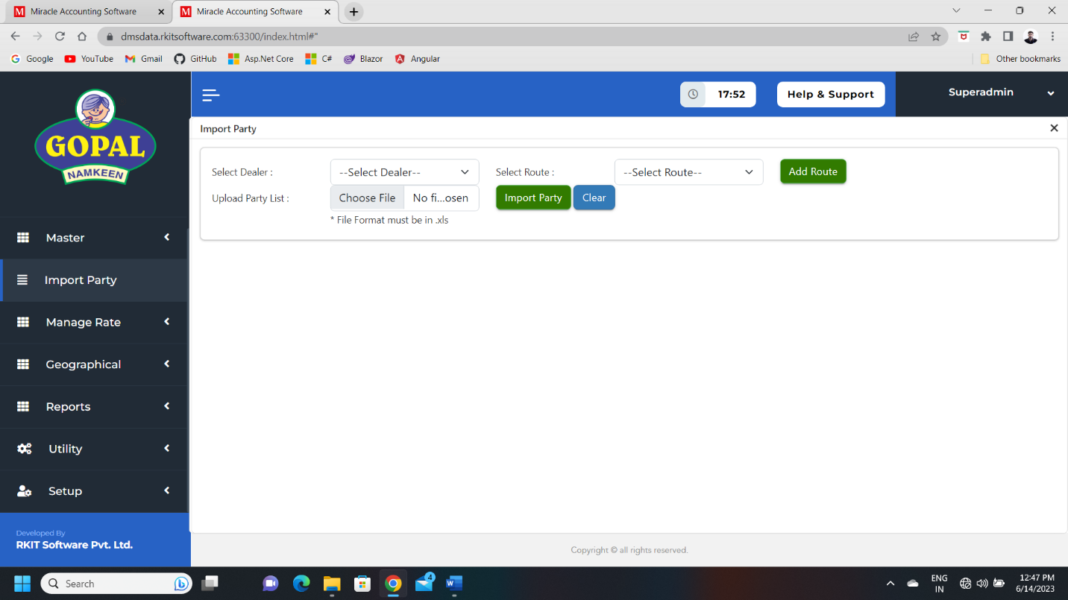
- In this section we can import party using excel sheet to particular dealer.

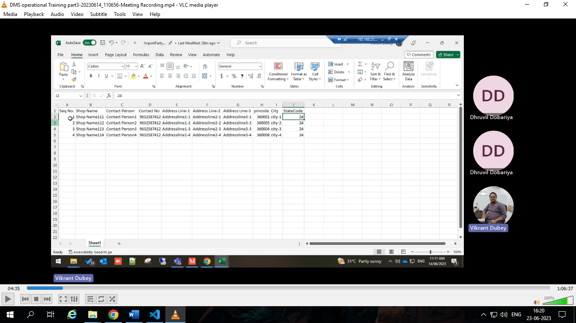
- We must give all required field in excel.

Manage Rate(Superadmin)

Introduction
- In this section we have four components,
  - Region wise rate
  - Dealer wise rate
  - Assign Rate/Product
  - Price Category

Region wise rate
- In this component we manage region wise rate and conversion factor.
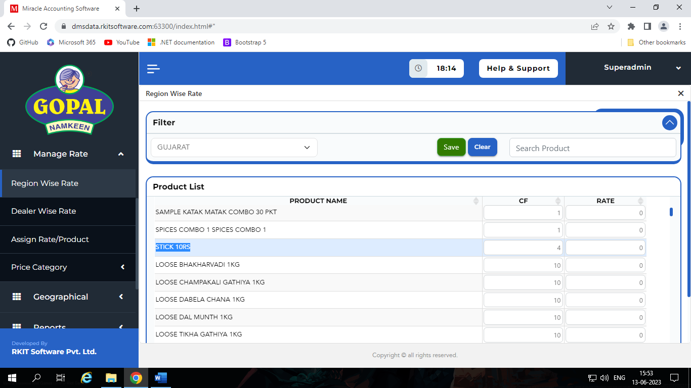

Dealer wise rate
- In this component we manage dealer wise rate and conversion factor.
- Dealer wise rate have more priority than region wise rate.
- So, if we don’t assign dealer wise rate then and only then region wise rate give effect else dealer wise rate give effect on product rate.
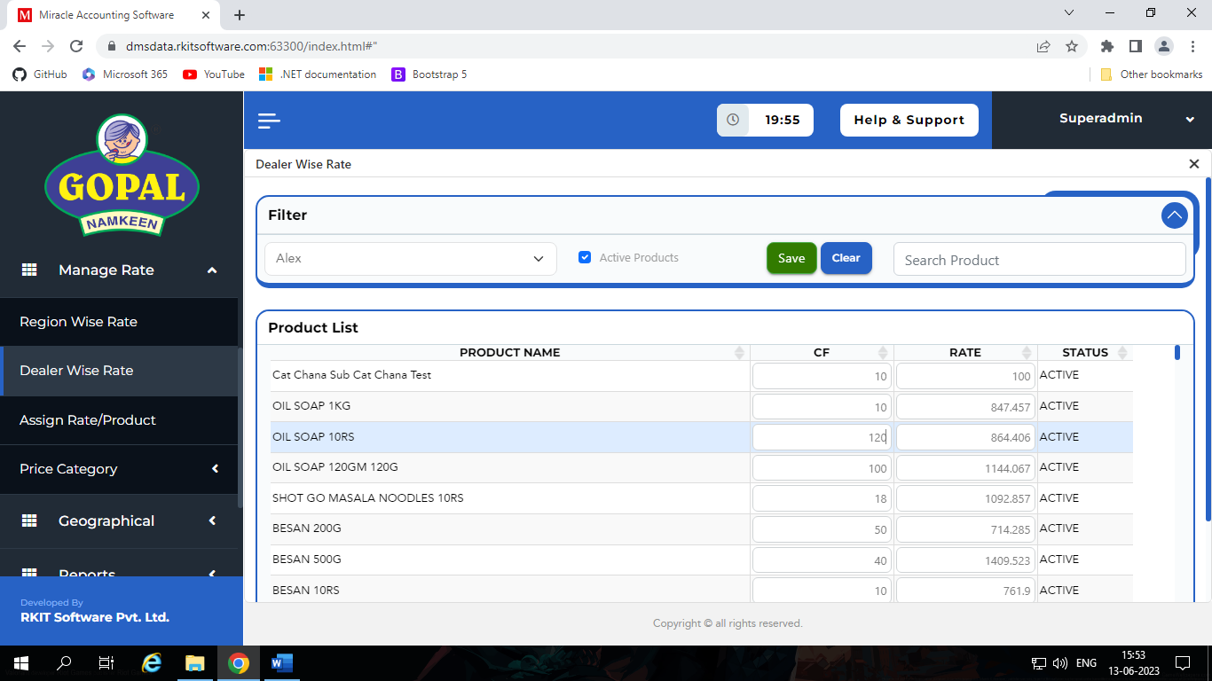

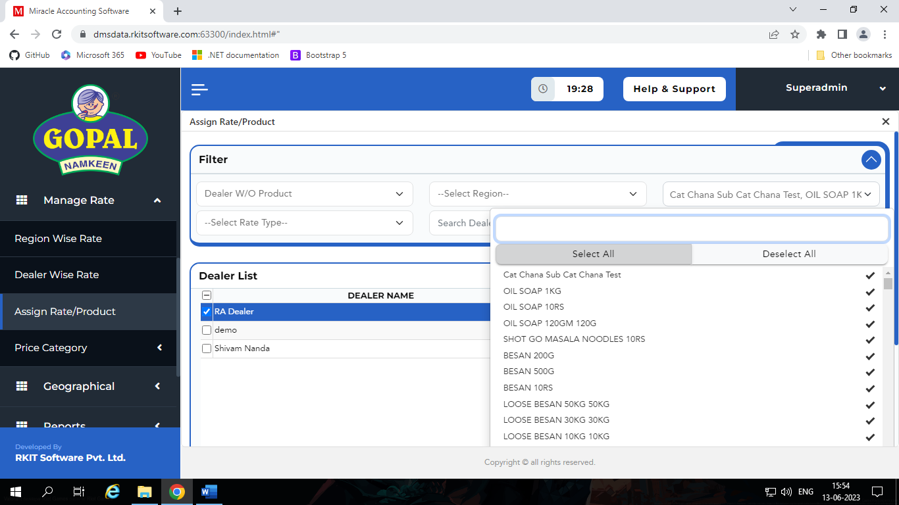
Assign Rate/Product

- In this component we can assign product, product rate and conversion factor to particular dealer or all dealer, in other word we can specify which dealer can sale which products.
- By default when we assign some product to dealer they so selling rate and conversion factor which we set selling rate at creation time of product include commodity.
- If we want to change rate and conversion factor then we first set rate from dealer wise rate or region wise rate.
- But it’s not work if we only set rate in dealer wise rate or region wise rate.
- After we set rate or conversion factor we must assign rate and conversion factor to particular dealer from assign rate/product.

Price Category
- It contains three different components,
  - Zone
  - Region
  - Area
- It helps use to manage price list on region.
Zone:
- Zone means state that contains different regions.
- Ex: Gujarat, Maharashtra, Goa, Delhi…
Region:
- Region means different part of state which contains different areas.
- Ex: Saurashtra Nort Gujarat, South Gujarat, Kachchh, Middle Gujarat…
Area:
- Area contains different part of regions.
- Ex: Rajkot City, Rajkot Ruler, Ahmedabad City…

Geographical(Superadmin)

Introduction
- It is help us to manage different geographical details in every entity like dealer, product and other.
- It contains five components,
  - Country
  - State
  - District
  - Taluka
  - City

Utility(Superadmin)

Introduction
- In this section we have twelve component, which is,
  - Manage Salesman
  - Assign Route
  - Dealer Notice
  - Bill Price Edit
  - Manage Team
  - Change Party Name
  - Manage Party
  - Manage Route
  - Manage Pricelist File
  - Manage Dashboard Image
  - Reset Password
  - Edit Company

Manage Salesman
- In this component we can manage salesman of our dealers.
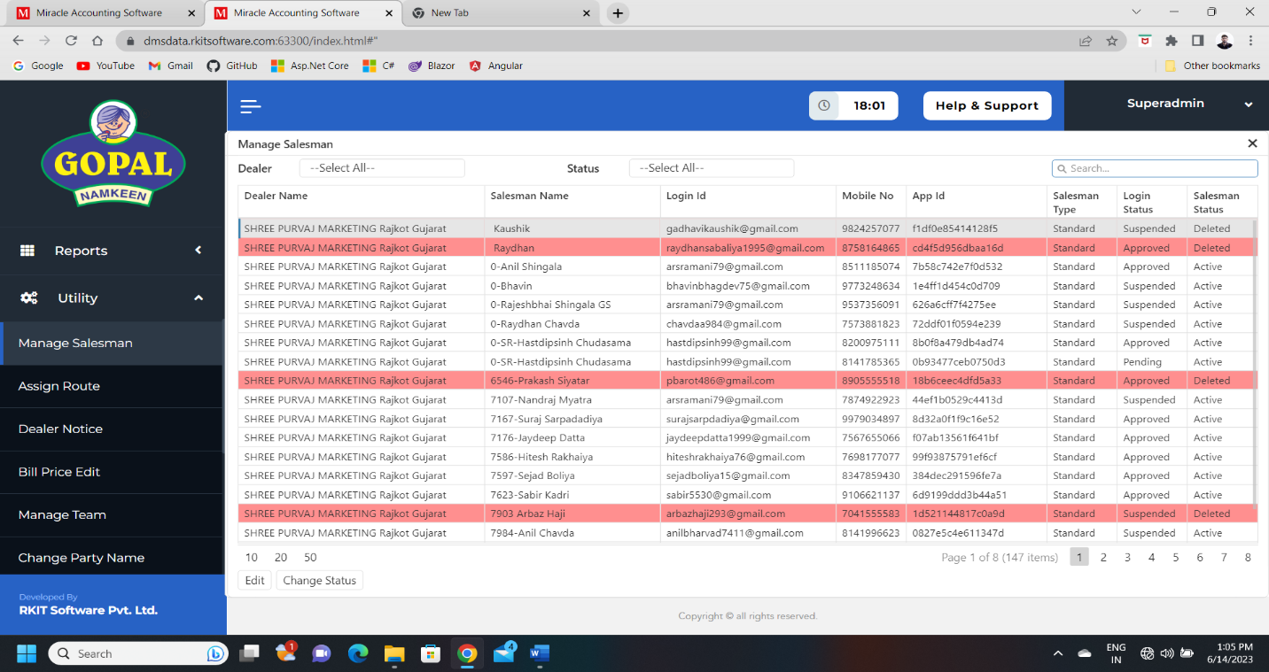
- We also can change status of our dealer.

Assign Route
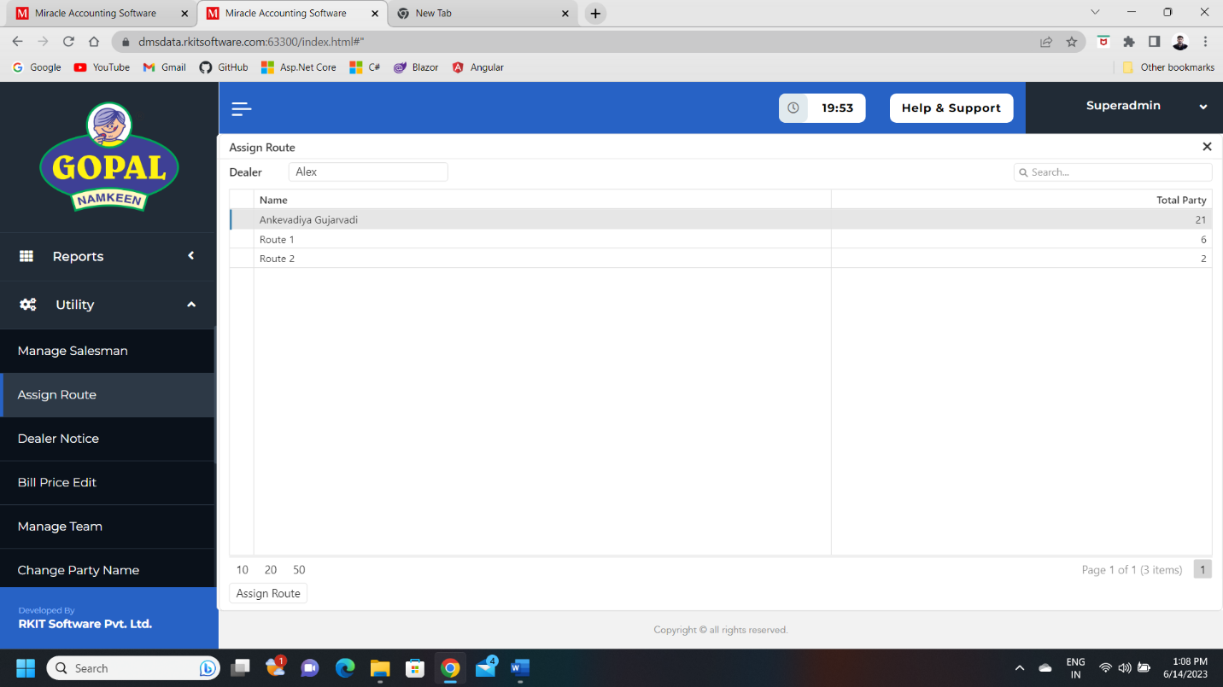
- In this section we can assign route of one dealer to another dealer.

Dealer Notice
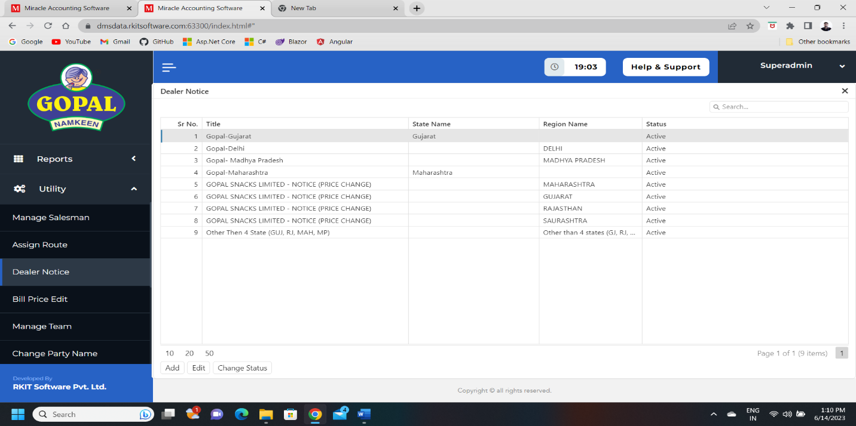
- In this section we can manage notice that we want show on front page of dealer.
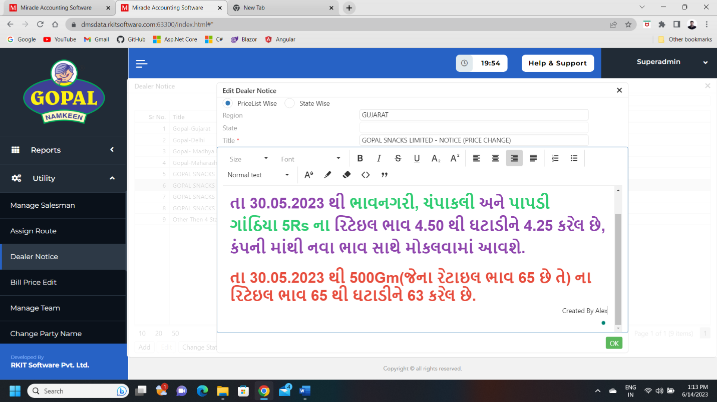
- We can manage it state vice and pricelist wise.

Bill Price Edit
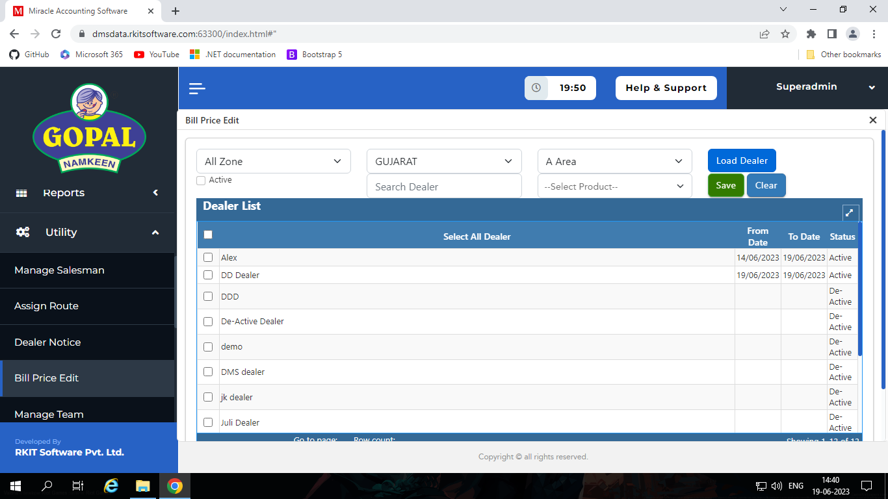
- In this section we can allow to dealer to edit price of product in sales order.

Manage Team
- In this section we can create user and add in particular team.
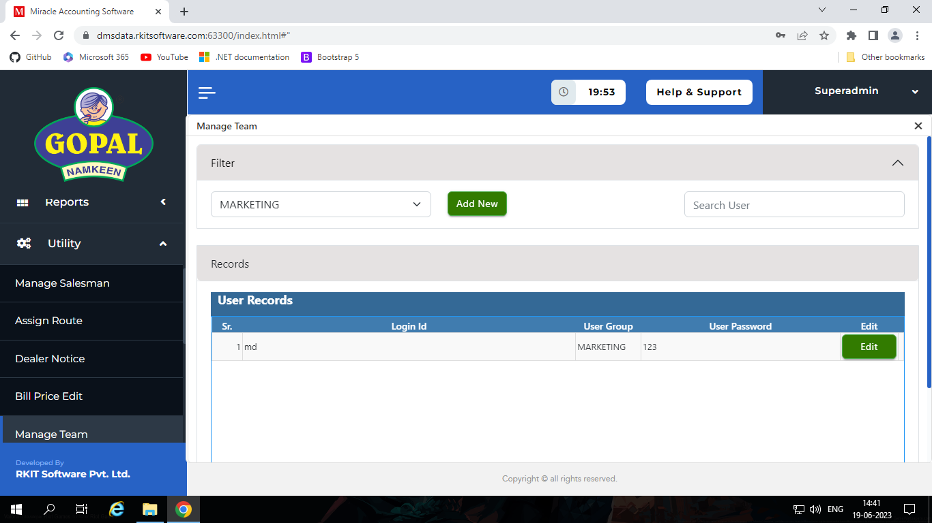
- We may have various teams like admin team, report team, marketing team, dealer team…

Change Party Name
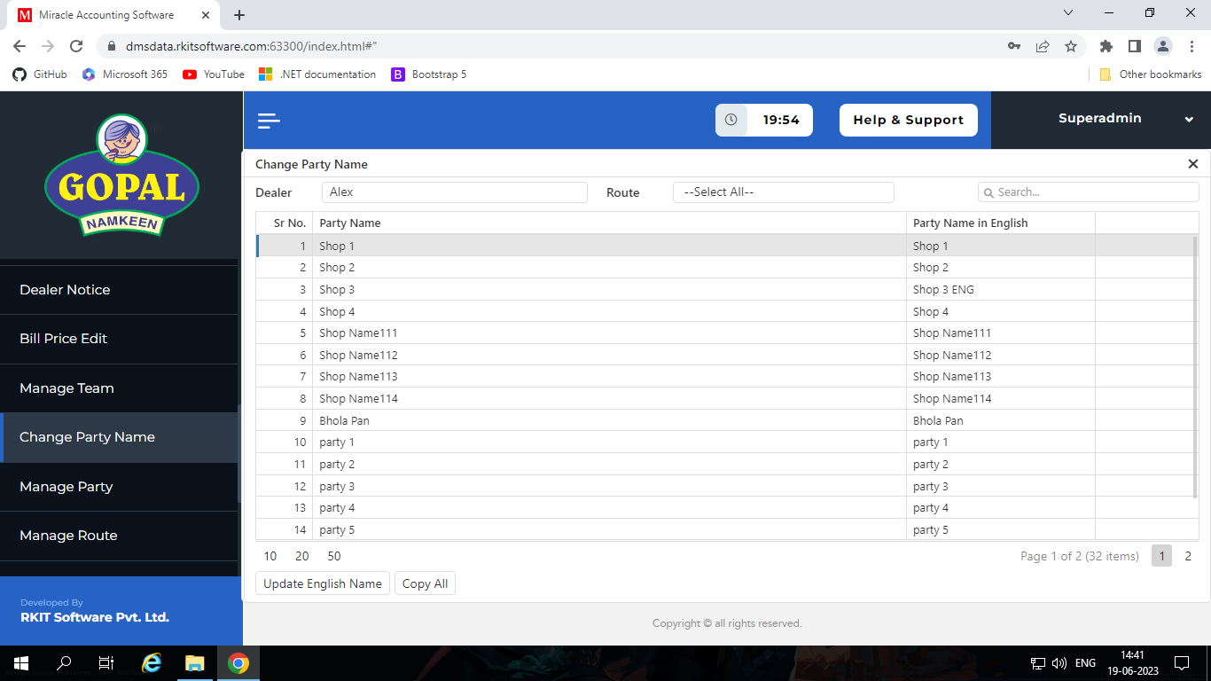
- In this section we can change English name of parties of dealers.

- If we want to set all the parties English name same as parties name then we don’t need to update one by one, we just click Copy All.

Manage Party
- In this section we can manage parties of different dealer and its state.
- Because when dealer de-active any party the they don’t see that party.
- So, if they want to re-active that party then they must take help of admin.
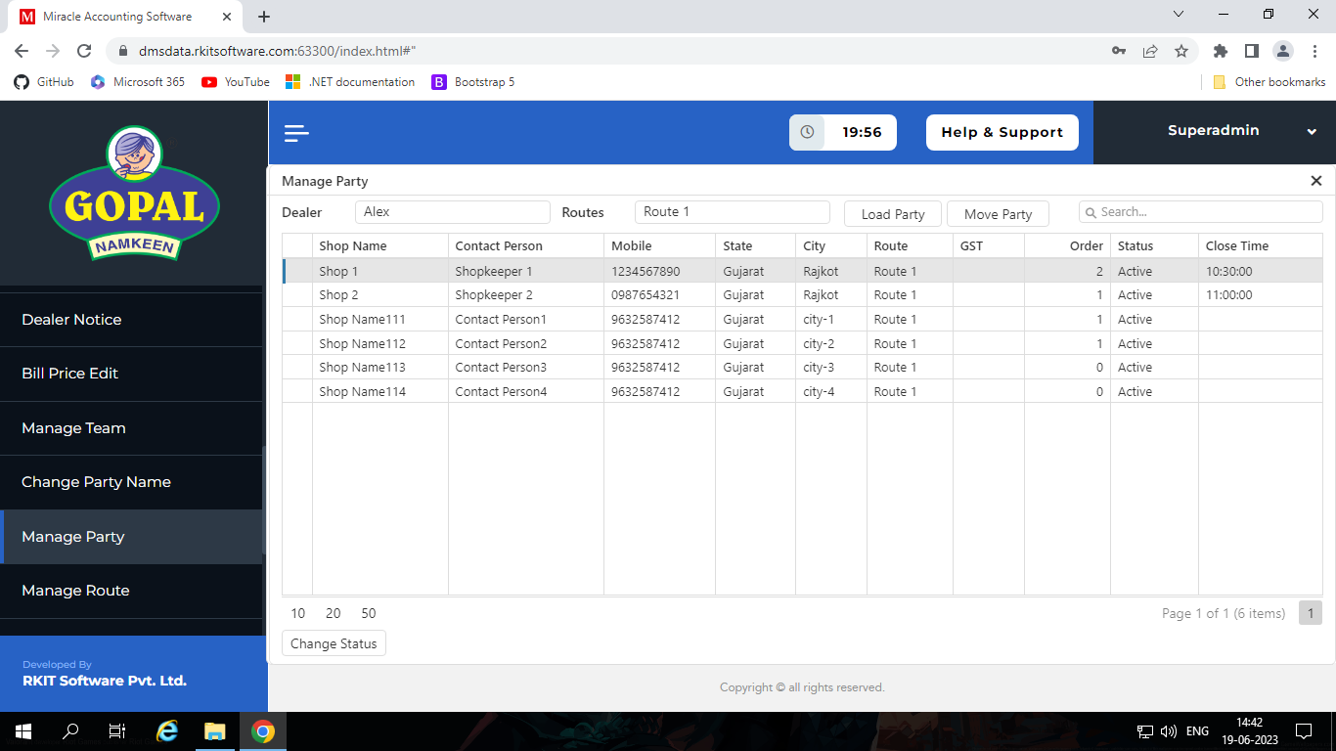
- So, admin can re-active or any other state assign to any party.

Manage Route
- In this section we can manage routes of different dealer and its state.
- Because when dealer de-active any route the they don’t see that route.
- So, if they want to re-active that route then they must take help of admin.
- So, admin can re-active or any other state assign to any route.
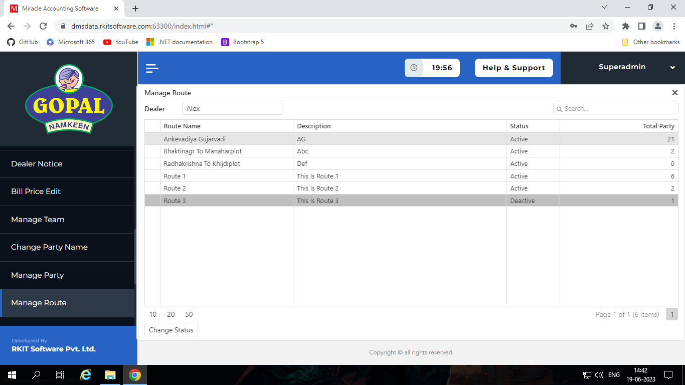

Manage Pricelist File
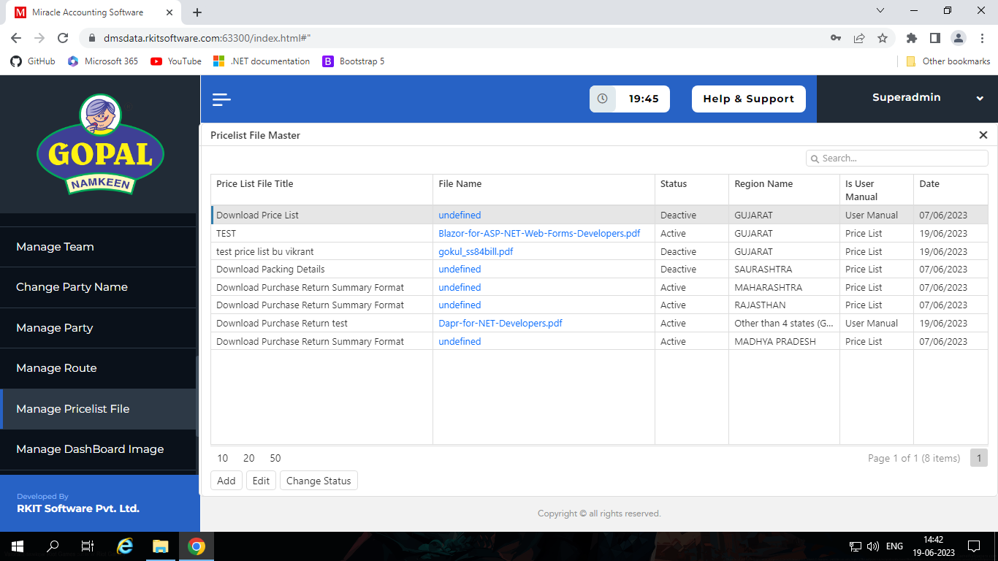
- In this section we can manage pricelist file and user manual for different region.

- These file show on welcome page of dealer portal and they can see and download it.
- If we set multiple files for one region then last one which have active state that will be see on welcome page of dealer dashboard.

Manage Dashboard Image
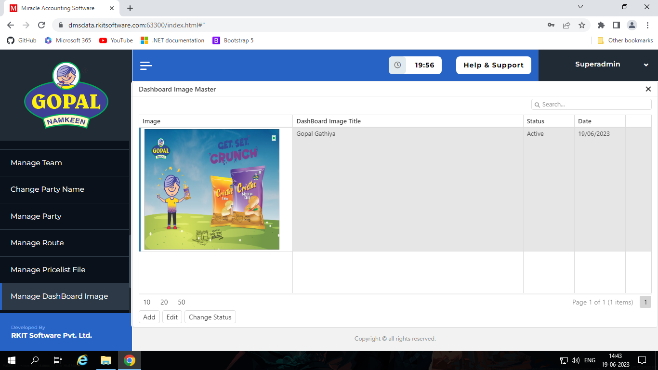
- In this section we can manage image which we want to show on welcome page of dealer portal.

- In this section we can only create one record.
- We also can change the state in Active / De-Active.

Reset Password
- In this section we can reset pass word of one or more user in one transaction.
- In this section we also see the past password.

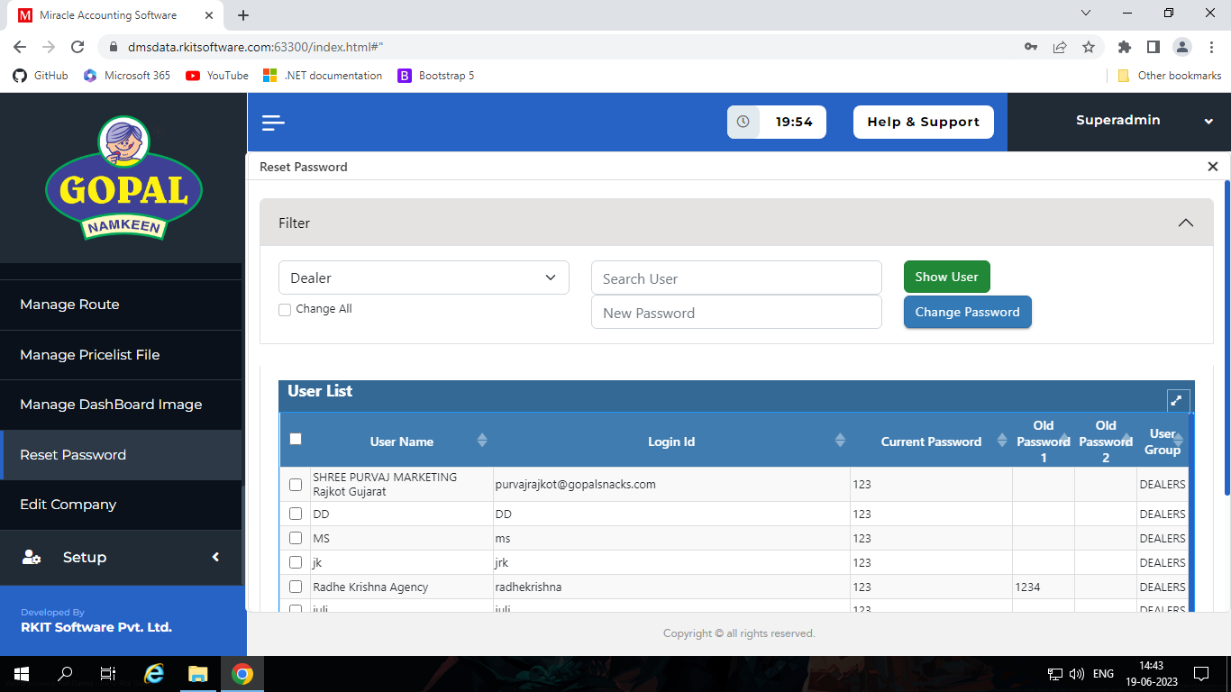

Edit Company
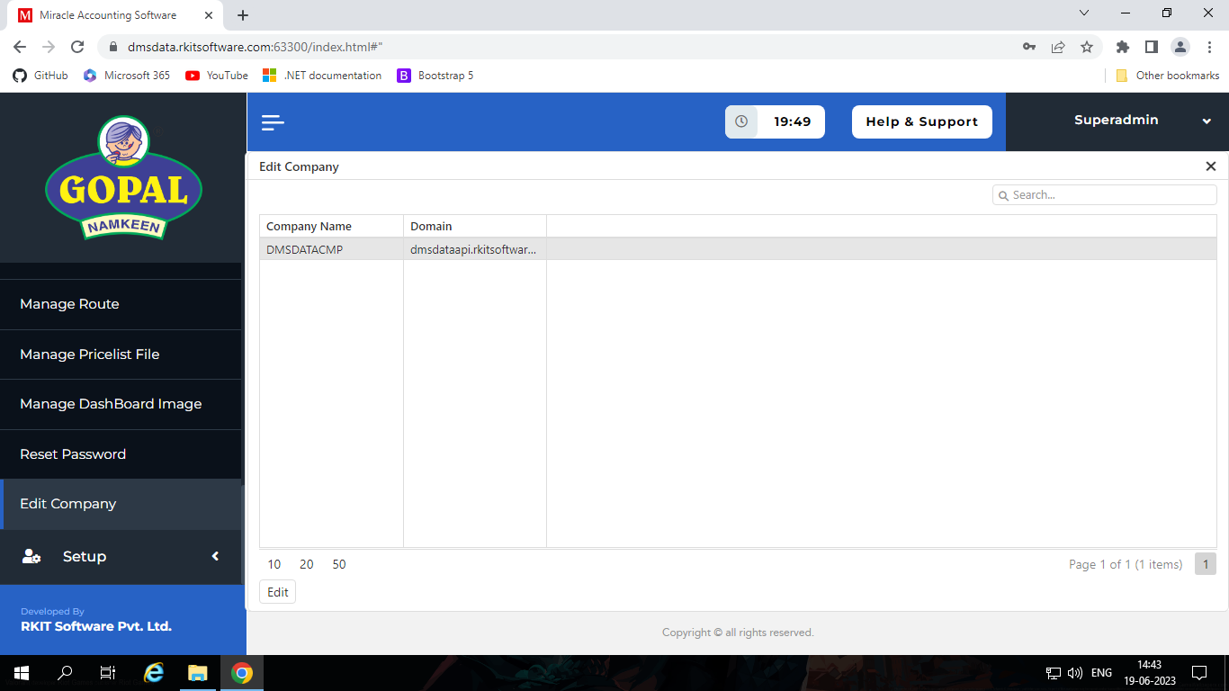
- In section we can manage details of company.

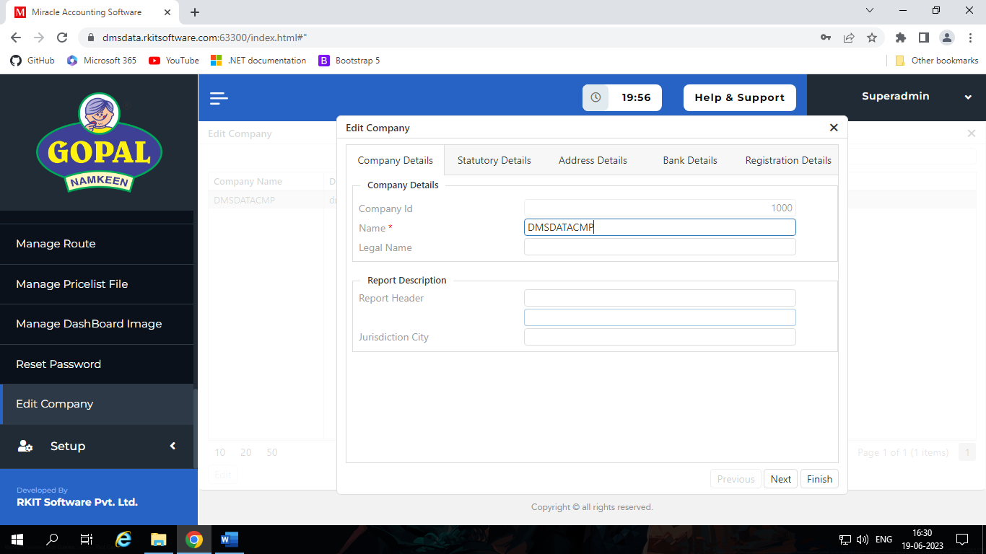

Report(Superadmin)

Introduction
- In this section we have multiple type reports like,
  - Sales Report
  - Purchase Report
  - Summary Report
  - Stock Report
  - Analysis Report
  - Other Report

Sales Report
- In this section we have different types of Sales Reports, like,
  - Sales Order
  - Sales Bill
  - Delete Order
  - Deleted Bill
  - Party Status
  - Sales Return
  - Sales Bill Register
  - Sales Order vs Bill Qty
- In each sales report we have some common filters like,
  - Financial year*
  - Range of Date*
  - State*
  - District
  - Dealer*
Sales Order:
- In this section we can see the report of sales order.
- This report contains some other filter like,
  - Route
  - Party
  - Salesman
  - Product
  - Pending Order / Generated Bill*
    - Pending Order
      - if bill of order is not generated.
    - Generated Bill
      - If bill of order if generated.
  - Active / Show Hidden*
    - If Route or Party is de-active or Salesman is pending or suspend their sales order don’t show dealer.
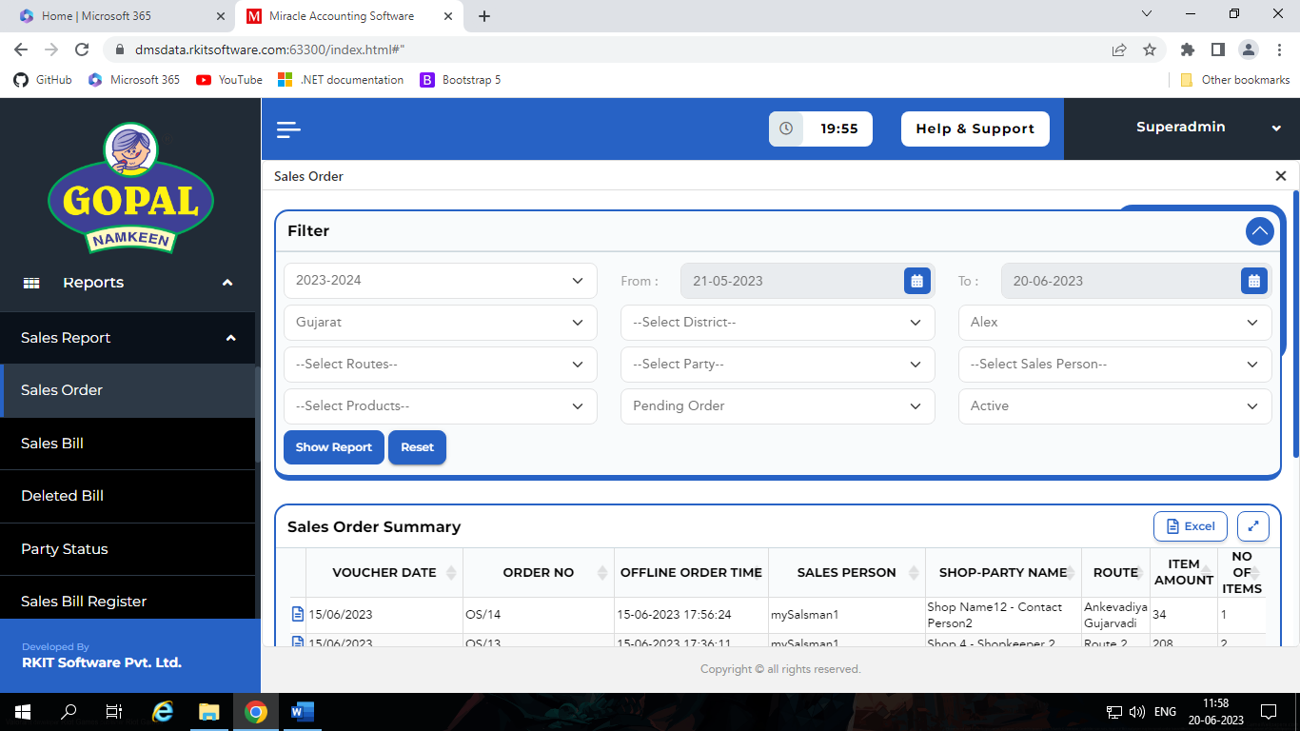
    - So if that type of order admin want to show then admin select Show Hidden.

Sales Bill:
- In this section we can see the report of sales bill.
- This report contains some other filter like,
  - Route
  - Party
  - Salesman
  - Product
  - Party Type*
    - Regular / Consumer / Unregistered / Composition
  - With Tax / Without Tax*
    - With Tax
      - It shows that sale bill return that’s bill generate with tax.
    - Without Tax
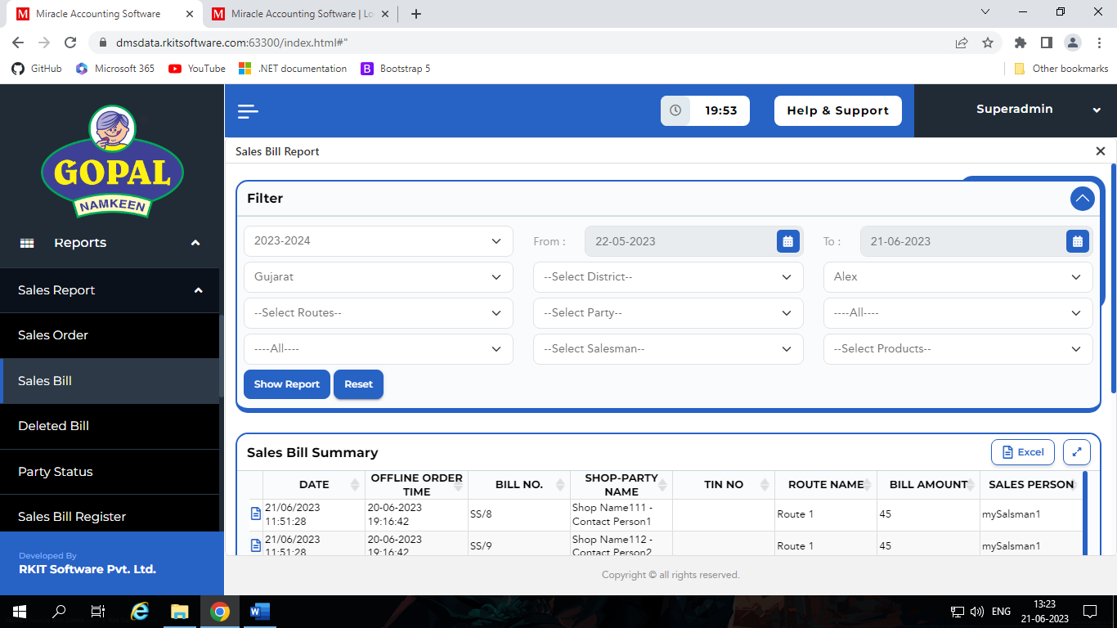
      - It shows that sale bill return that’s bill generate without tax.

Delete Order:
- In this section we can see the report of deleted sales order.
- This report contains some other filter like,
  - Route
  - Party

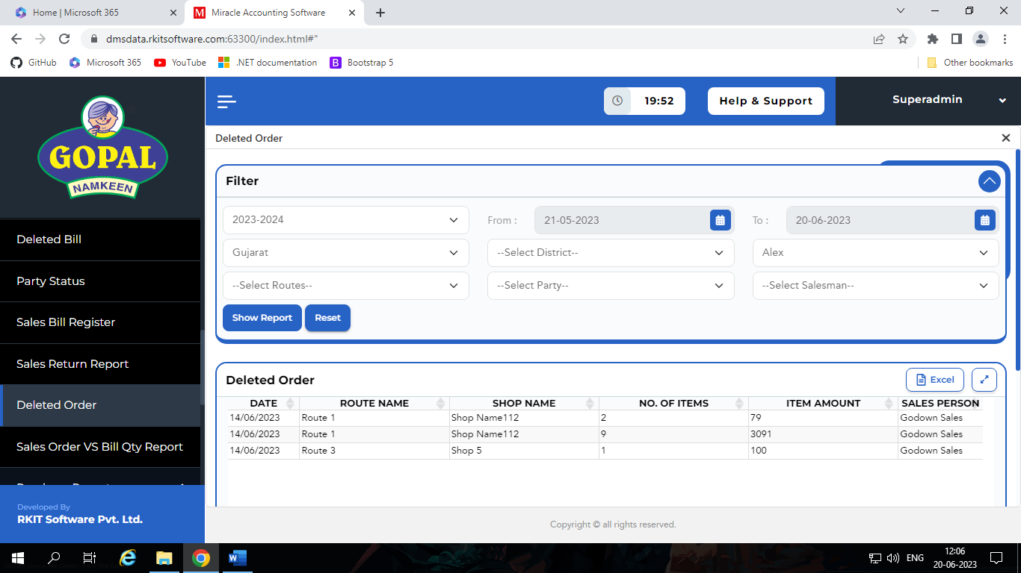

Deleted Bill:
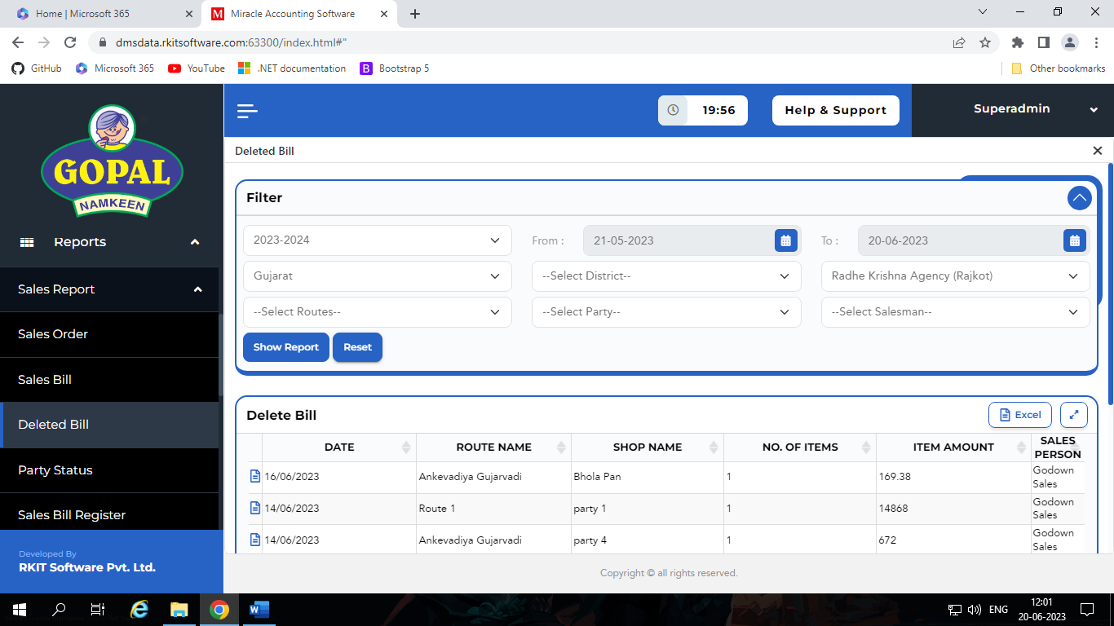
- In this section we can see the report of deleted sales bill.
- This report contains some other filter like,
  - Route
  - Party
  - Salesman
Party Status:
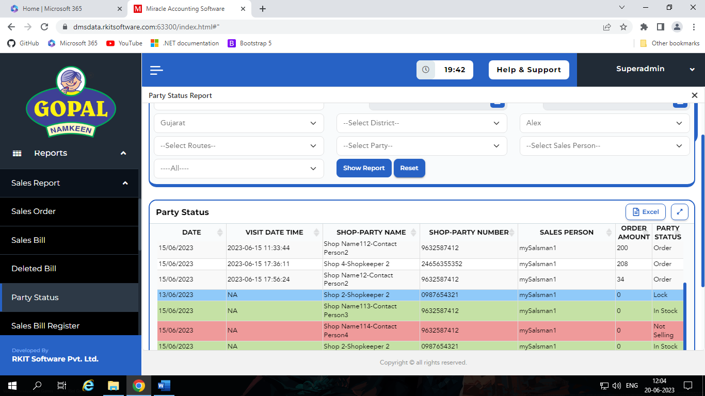
- In this section we can see the report of status of parties which is set by salesman when they go on shop to punch order.
- This report contains some other filter like,
  - Route
  - Party
  - Salesman
  - Status
    - Order / None / Lock / In Stock / Not Selling / Not Visited
Sales Return:
- In this section we can see the report of sale return.
- This report contains some other filter like,
  - Route
  - Party
  - Salesman
  - Product
  - Party Type*
    - Regular / Consumer / Unregistered / Composition
  - With Tax / Without Tax*
    - With Tax
      - It shows that sale bill return that’s bill generate with tax.
    - Without Tax
      - It shows that sale bill return that’s bill generate without tax.
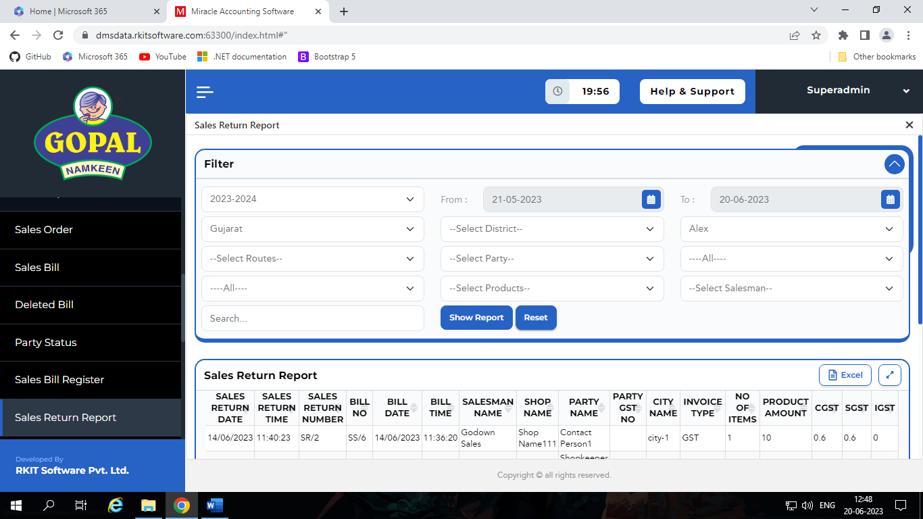
- We have also one search box for search appropriate record.

Sales Bill Register:
- In this section we can see the report of Sale Bill in detail.
- This report contains some other filter like,
  - Route
  - Party
  - Salesman
  - Product
  - Party Type*
    - Regular / Consumer / Unregistered / Composition
  - With Tax / Without Tax*
    - With Tax
      - It shows that sale bill return that’s bill generate with tax.
    - Without Tax
      - It shows that sale bill return that’s bill generate without tax.
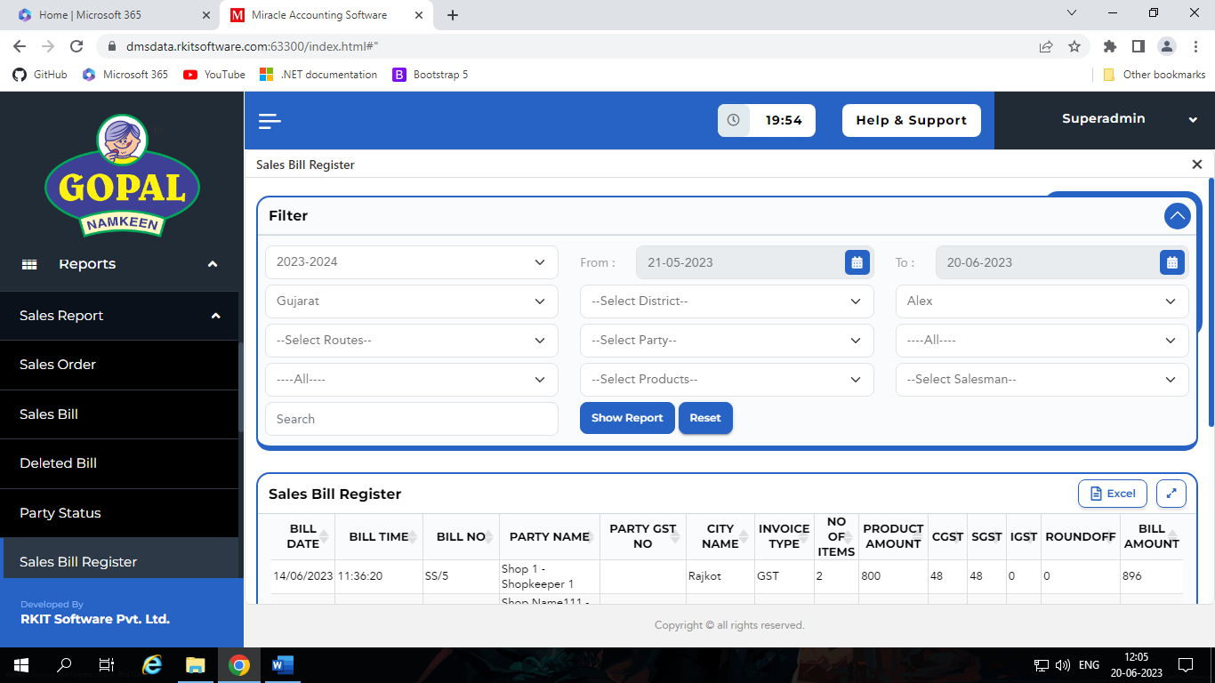
- We have also one search box for search appropriate record.

Sales Order vs Bill Qty:
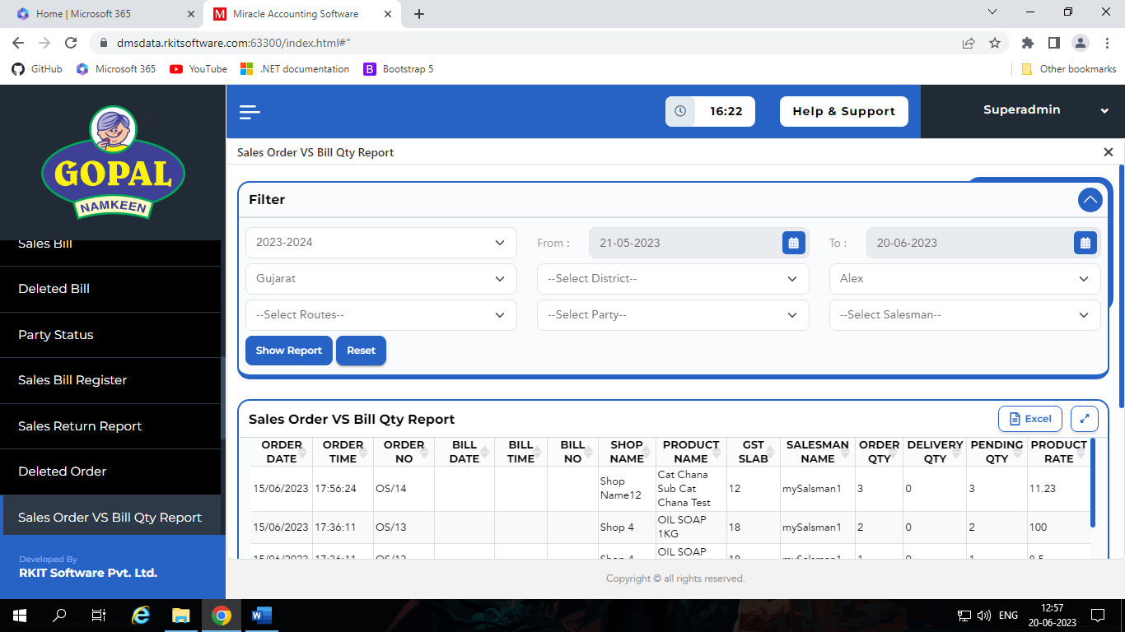
- In this section we can see the report of Sale Order vs Sale Bill.
- We can see the changes in quantity and price of Sale Order and Sale Bill which we are done at the time of invoice generation.
- We can also see the quantity of order, deliver quantity and pending quantity.
- This report contains some other filter like,
  - Route
  - Party
  - Salesman

Purchase Report
- In this section we have different types of Purchase Reports, like,
  - Purchase Bill
  - Multi Dealer Purchase Bill
Purchase Bill:
- In this section we can see the report of purchase bill.
- This report contains some filter like,
  - Financial Year*
  - Range of Date*
  - State*
  - District
  - Dealer*
  - PO – Number / Amount
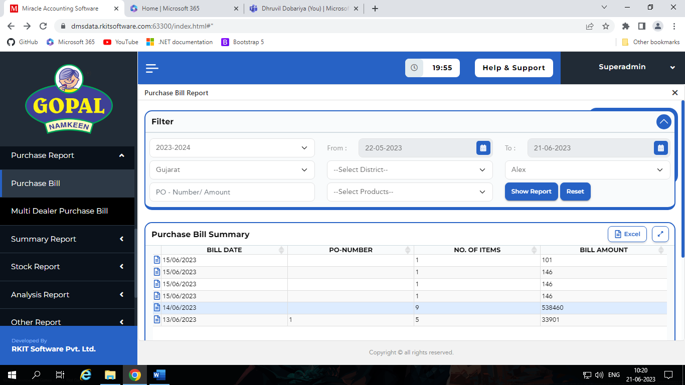
  - Product

Multi Dealer Purchase Bill:
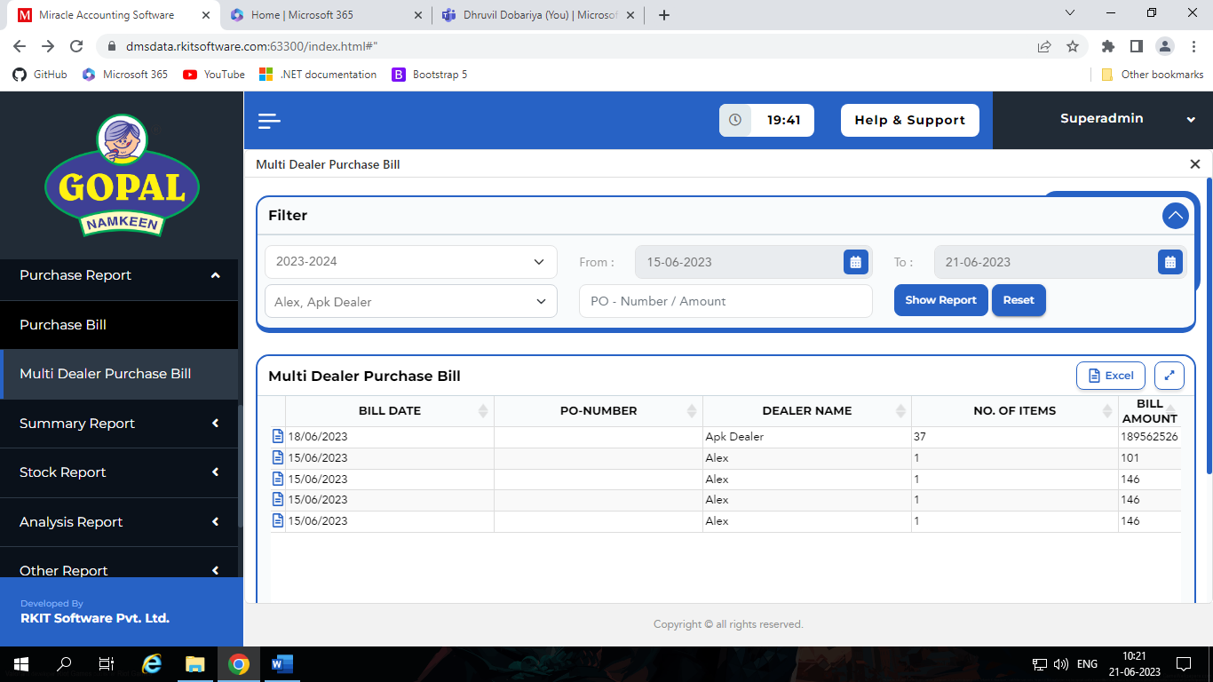
- In this section we can see the report of purchase bill of multiple dealers in one report.
- This report contains some filter like,
  - Financial Year*
  - Range of Date*
  - Dealer*
    - In this filter we can specify multiple dealer
  - PO – Number / Amount

Summary Report
- In this section we have different types of Summary Reports, like,
  - Dealer wise summary
  - Total summary
  - Salesman summary
  - Dealer transaction summary
Dealer wise summary:
- In this section we can see the report of date wise Dealer summary like,
  - How many sales man dealer have approved / active
  - We can see Day wise call, Day wise Route, Inactive call, Attended Call.
  - We also can see details about sale order, sale bill and sale return.
- This report contains some filter like,
  - Financial Year*
  - Range of Date*
  - State*
  - District
  - Dealer*
  - Active / Show Hidden*
    - If Route or Party is de-active or Salesman is pending or suspend, then their related activity record doesn’t see the dealer.
    - So, if that type of detail admin want to show then admin select Show Hidden.
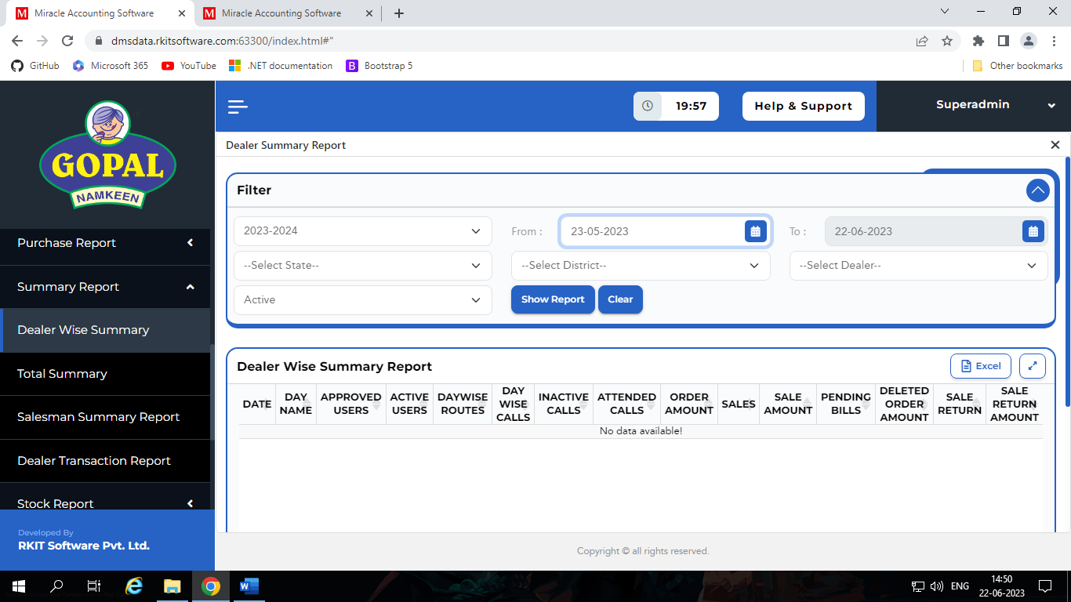
Total summary:
- In this section we can see the report of date wise and dealer wise total summary.
- It is same as dealer summary, but here we can see summary of multiple dealers in one report.
- This report contains some filter like,
  - Financial Year*
  - Date*
  - State
  - Active / Show Hidden*
    - If Route or Party is de-active or Salesman is pending or suspend, then their related activity record don’t see the dealer.
    - So if that type of detail admin want to show then admin select Show Hidden.
- We also have one search box to find appropriate dealer.
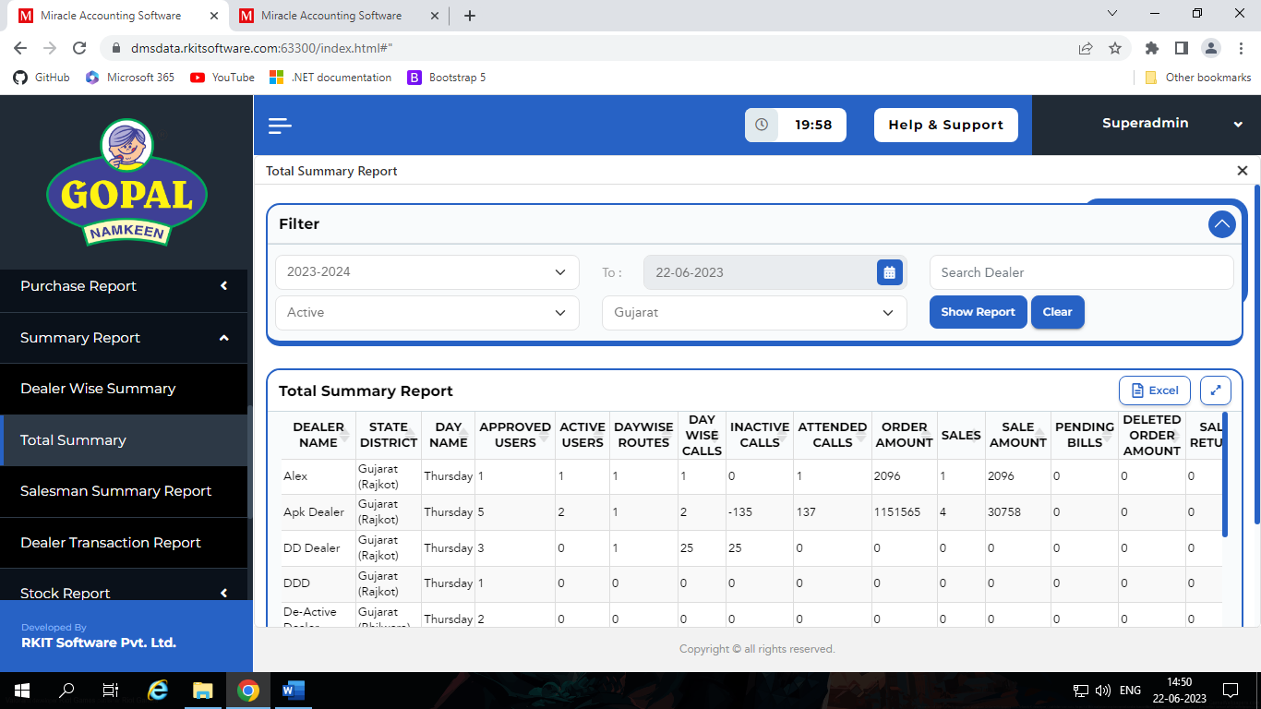
Salesman summary:
- In this section we can see the report of Salesman summary like,
  - Which salesman, how many order punch and what is amount of order and their number of bills and amount of bill.
  - We also can see that which dealer give how many statuses to party like, lock, in stock and not selling.
- This report contains some filter like,
  - Financial Year*
  - Range of Date*
  - State*
  - District
  - Dealer*
- We also have one search box to find appropriate salesman.
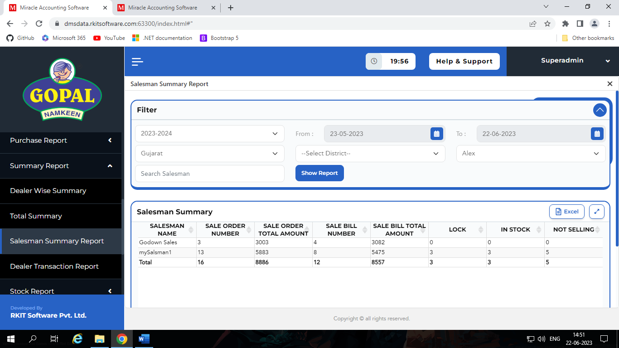
Dealer transaction summary:
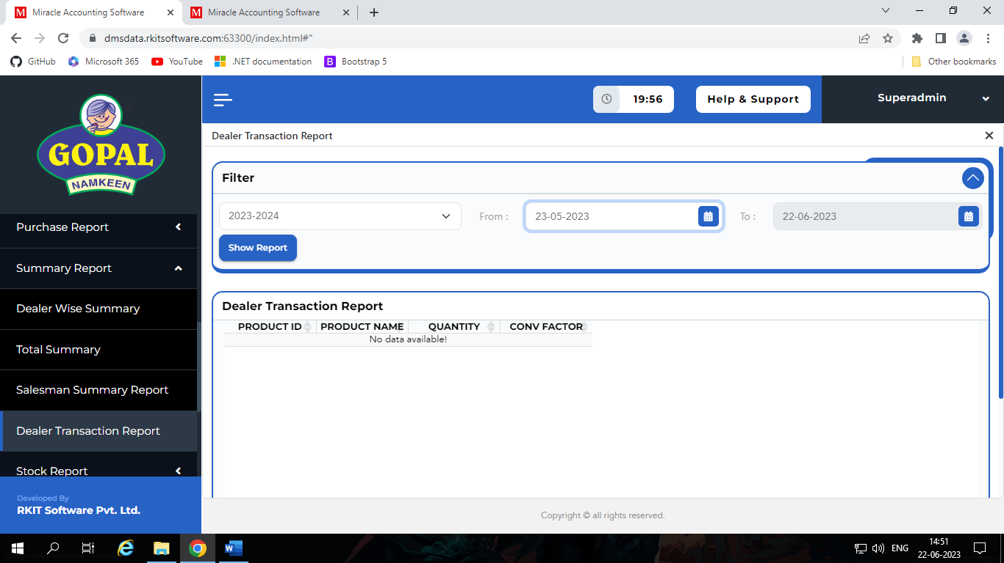
- In this section we can see the report of product transaction from company to dealer.
- In other word we can see which product company supplied to dealer in which quantity in which duration of date.
- This report contains some filter like,
  - Financial Year*
  - Range of Date*

Stock Report
- In this section we have different types of Stock Reports, like,
  - Current Stock
  - Current Stock with details
  - Negative Stock
  - Physical Voucher
  - Total Stock
Current Stock:
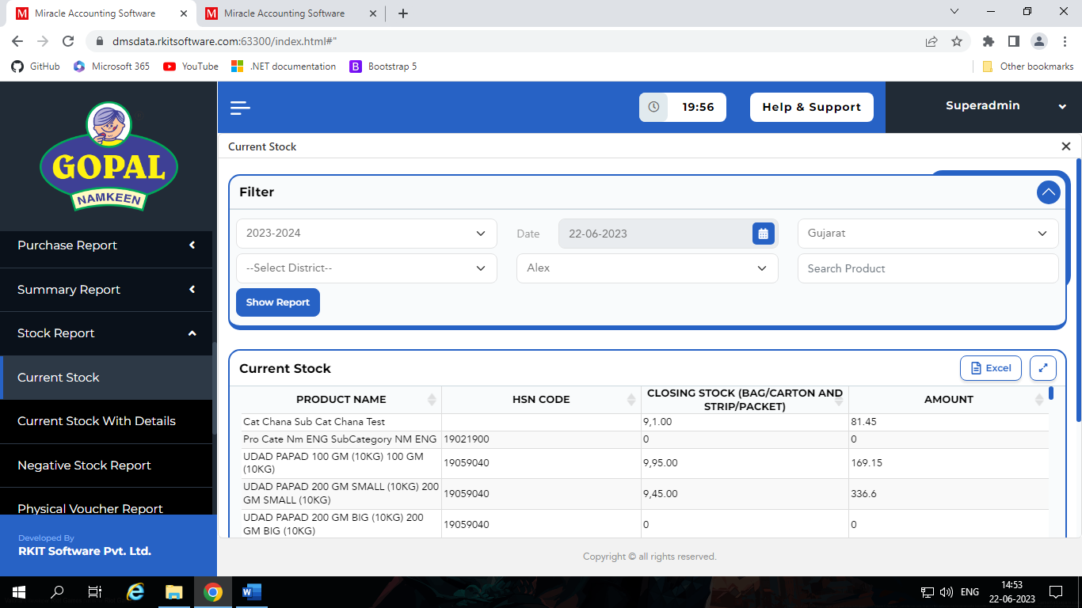
- In this section we can see the report of current stock of dealers.

- This report contains some filter like,
  - Financial Year*
  - Date*
  - State*
  - District
  - Dealer*
- We also have search box for find appropriate product.
Current Stock with details:
- In this section we can see the report of current stock of dealers in detail.
- This report contains some filter like,
  - Financial Year*
  - Range of Date*
  - State*
  - District
  - Dealer*
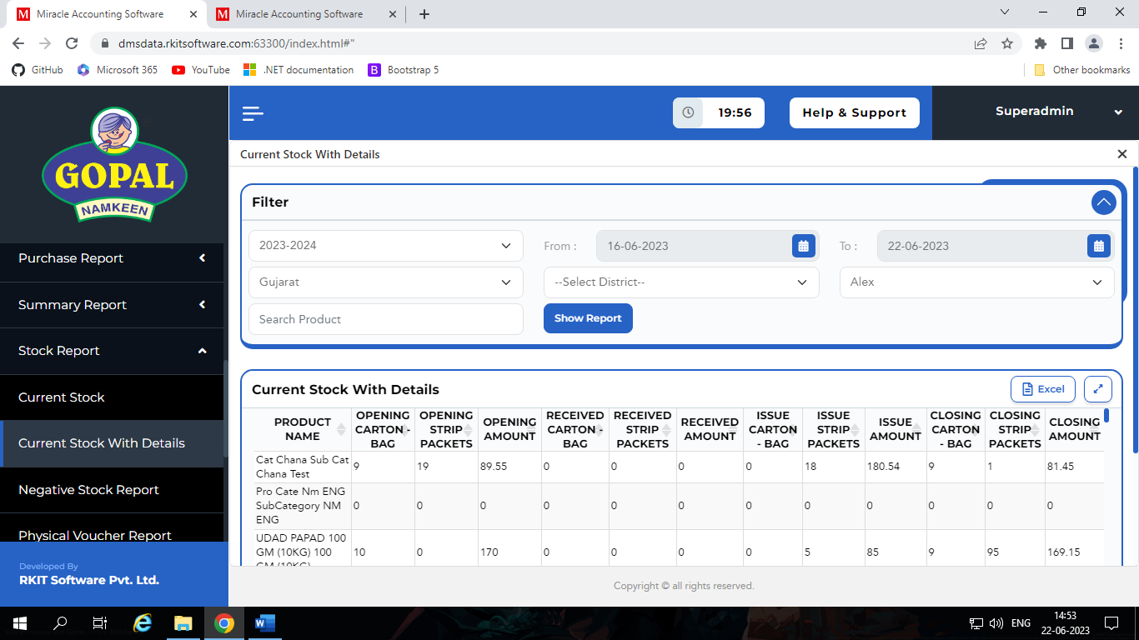
- We also have search box for find appropriate product.

Negative Stock:
- In this section we can see the report of current stock of dealers.
- This report contains some filter like,
  - State*
  - District
  - Taluka
  - City
  - Only Negative Stock / Both Stock
- We also have search box for find appropriate product.
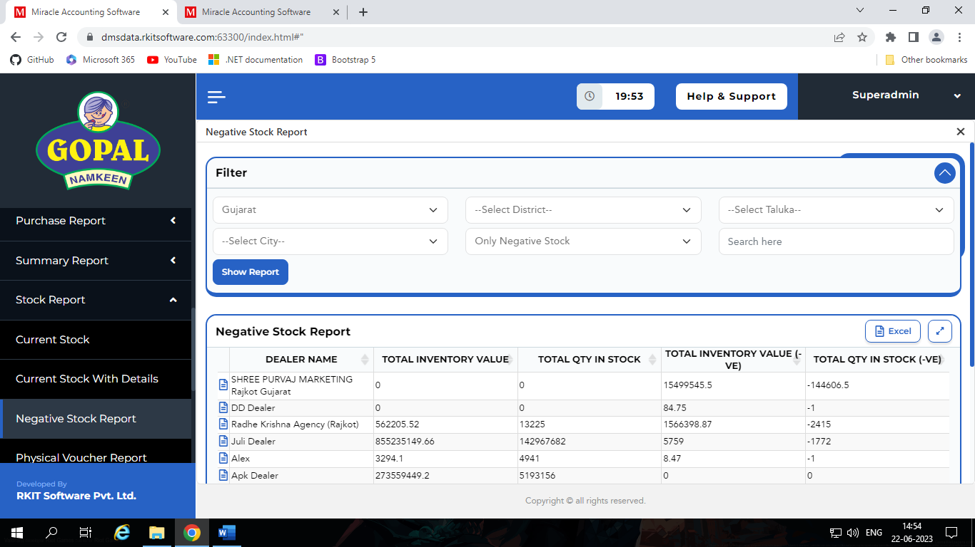
Physical Voucher:
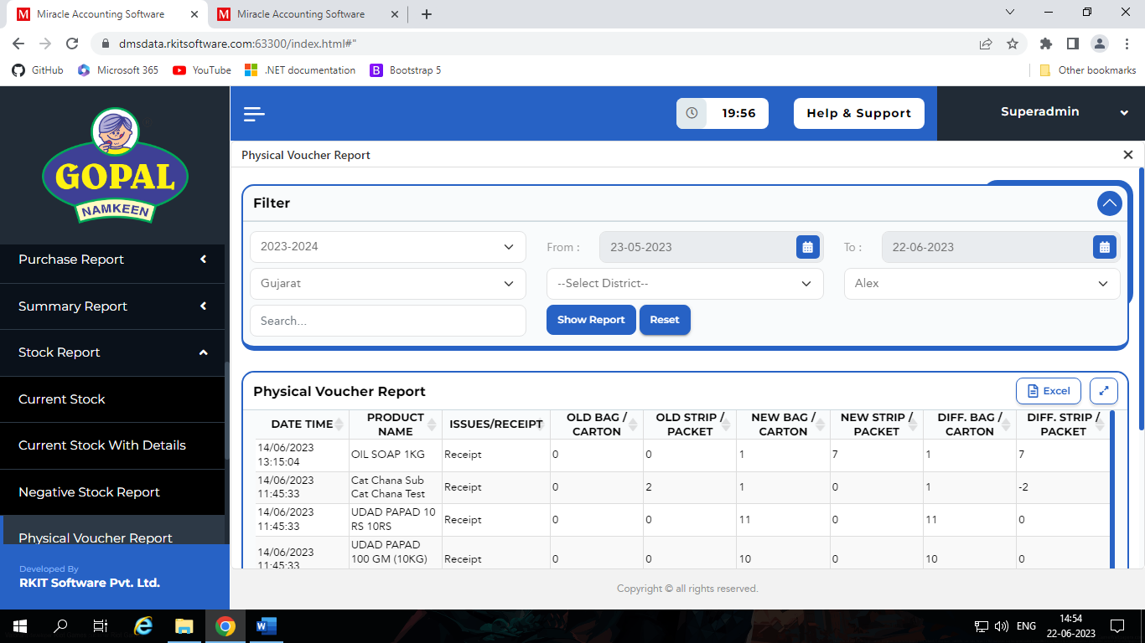
- In this section we can see the report of physical voucher which is add by dealers.
- This report contains some filter like,
  - Financial Year*
  - Range of Date*
  - State*
  - District
  - Dealer*
- We also have search box for find appropriate item.
Total Stock:
- In this section we can see the report of total stock of multiple dealers in one report.
- This report contains some filter like,
  - Financial Year*
  - Date*
  - State*
  - District
  - Taluka
  - City
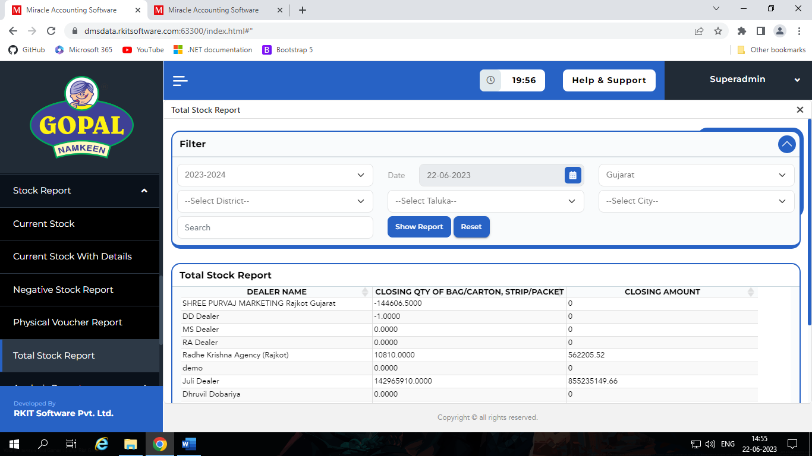
- We also have search box for find appropriate item.

Analysis Report
- In this section we have different types of Analysis Reports, like,
  - Route Analysis
  - Salesman Item Analysis
  - Party Visit Frequency Analysis
  - Call Placement Analysis
  - Daily Route Sales Status Analysis
Route Analysis:
- In this section we can see the report of how many routes salesman should visit on particular day.
- This report contains some filter like,
  - Financial Year
  - State
  - District
  - Day
    - Specify day of week
  - Active / Show Hidden
    - If Route or Party is de-active or Salesman is pending or suspend, then their related activity record doesn’t see the dealer.
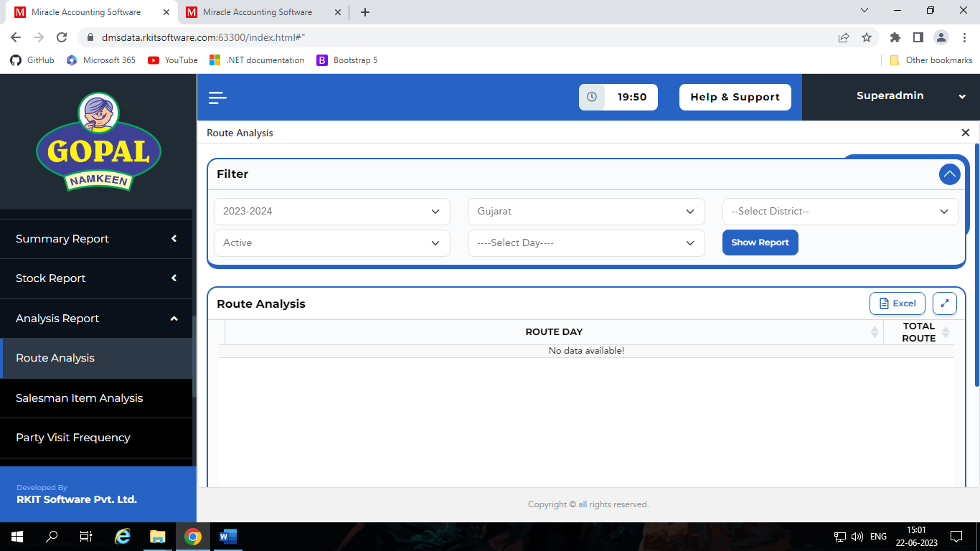
    - So, if that type of detail admin want to show then admin select Show Hidden.
Salesman Item Analysis:
- In this section we can see the report of which product sales in which quantity and total amount by dealer in particular month and whole year.
- We also see this report for particular salesman of dealer.
- We have different types of filters for this report like,
  - Financial Year*
  - Range of Date *
  - State*
  - District
  - Dealer*
  - Salesman
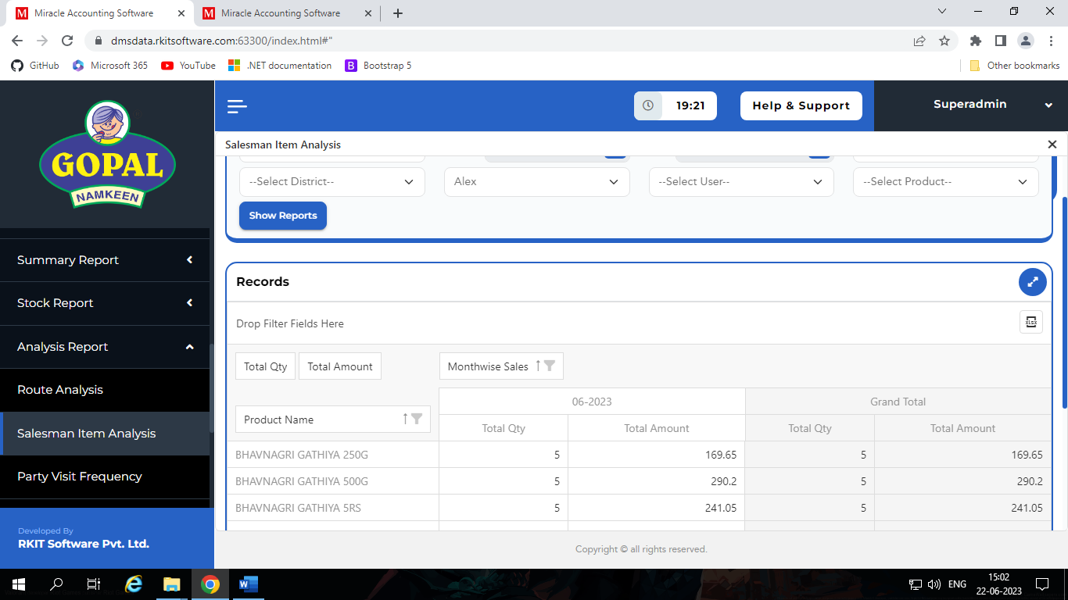
  - Product

Party Visit Frequency Analysis:
- In this section we can see the report of detail about how many parties visited by salesman base on dealer.
- In this report we can see,
  - Which dealer’s salesman visited how many parties and what is status of that parties and how many order punch in particular duration of time by salesman of dealer.
- This report contains some filter like,
  - Range of Date*
  - Active / Show Hidden*
    - If Route or Party is de-active or Salesman is pending or suspend, then their related activity record doesn’t see the dealer.
    - So, if that type of detail admin want to show then admin select Show Hidden.
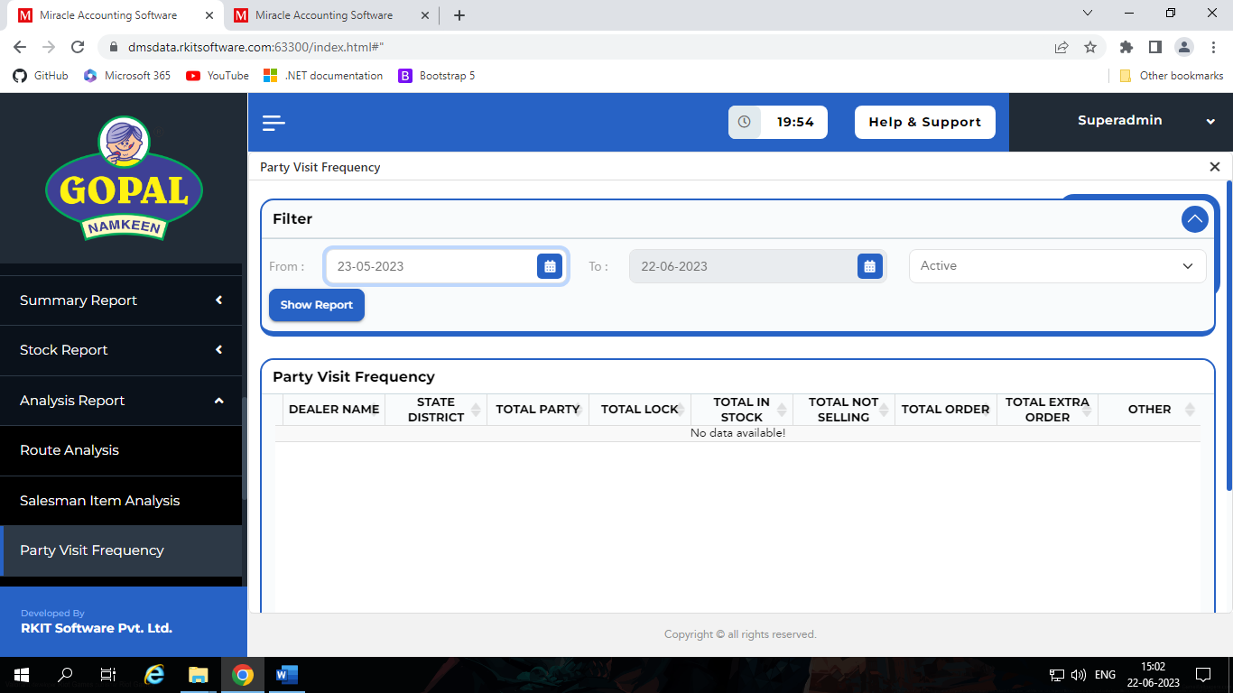
Call Placement Analysis:
- In this section we can see the report of details about which product exist in how many invoices for dealer.
- We also can see the count that product exist in how many invoices by particular salesman.
- Dealer count is depending on their regular salesman, it don’t include any count of warehouse sale.
- But we also can see the count that describe how many invoices contains this product for warehouse sales.
- We have different types of filters for this report like,
  - Financial Year*
  - Range of Date *
  - State
  - District
  - Dealer
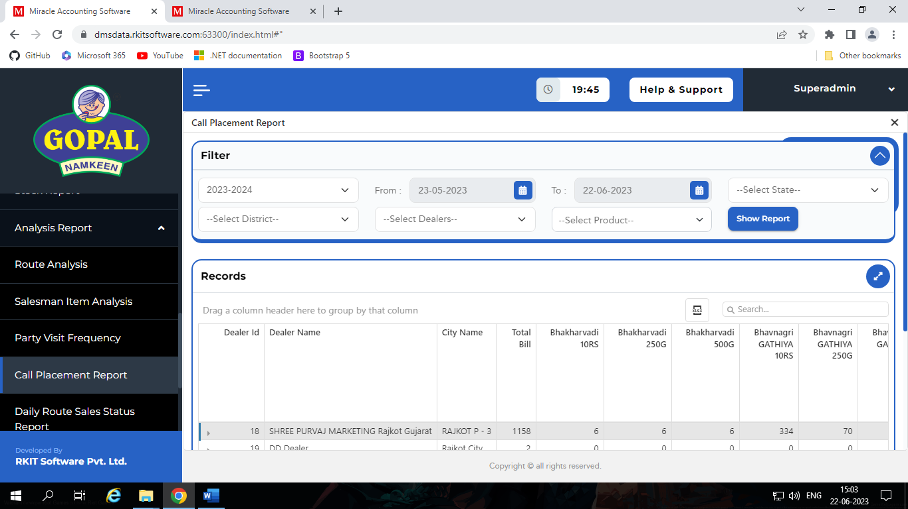
  - Product

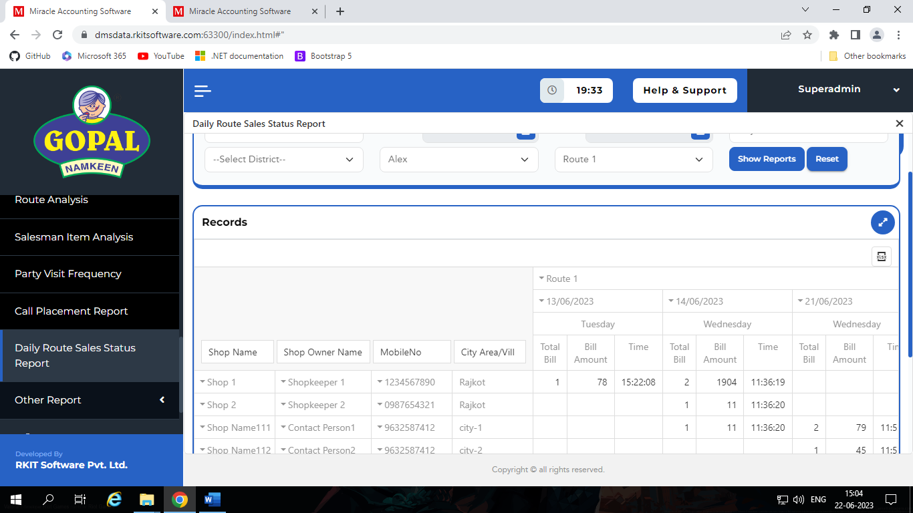
Daily Route Sales Status Analysis:
- In this section we can see the report of details about sale of route.
- We can see the details about sale bill of different shops which is exist on particular route based on day by day.
- This report contains some filter like,
  - Financial Year*
  - Date of Range*
  - State*
  - District
  - Dealer*
  - Route*

Other Report
- In this section we have different types of Other Reports, like,
  - Vehicle Report
  - Activity Log Report
Vehicle Report:
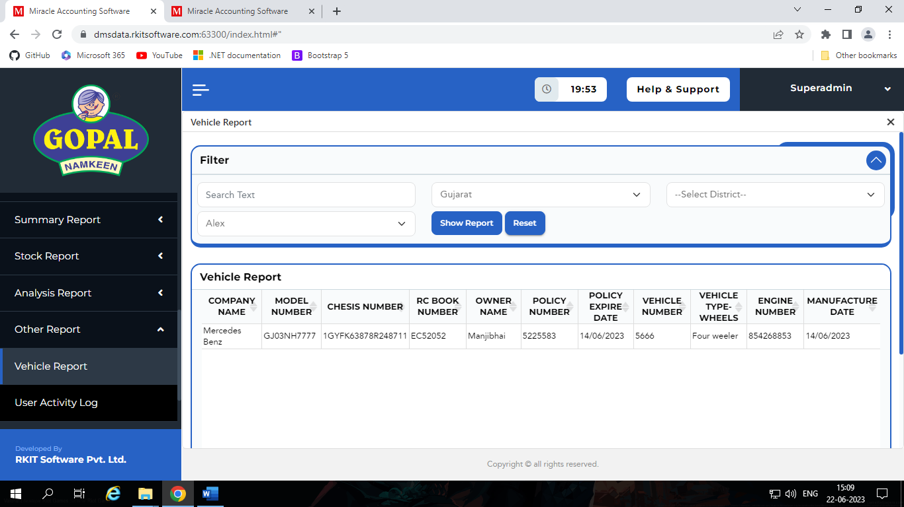
- In this section we can see the report of vehicle of dealers.

- We have different types of filters for this report like,
  - State*
  - District
  - Dealer*
- We also have one search box to search appropriate vehicle.
Activity Log Report:
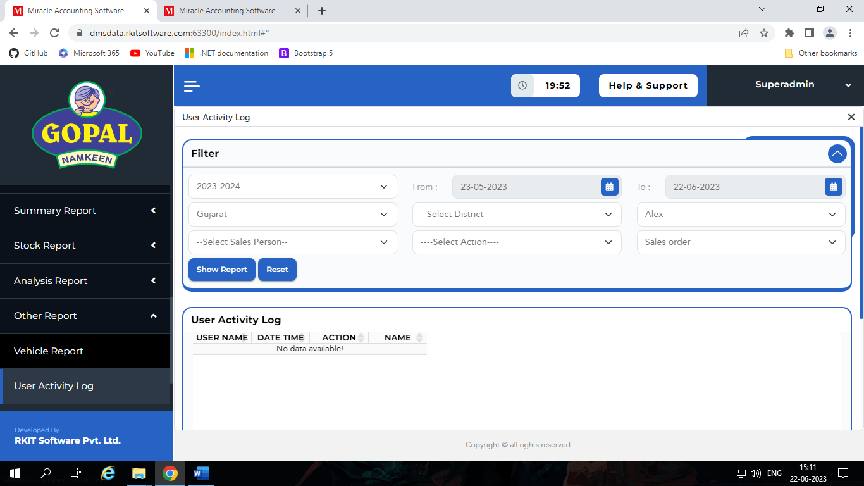
- In this section we can see the report of activities dealer and salesman.

- We have different types of filters for this report like,
  - Financial Year*
  - Range of Date *
  - State*
  - District
  - Dealer*
  - Salesman
  - Action
    - Add / Update / Delete
  - Module*
    - Sale Order / Sale Bill / Party Master / Physical Voucher / Sale Return / User Master / Route Master / Vehicle Master

Setup(Superadmin)

Introduction
- In this section we have three components which is,
  - Company Setup
  - Voucher Setup
  - User Security

User Security
- In this section we have three components,
  - User
  - User Group
  - User Right
User:
- It is used to create user.
- It contains different types of fields like,
  - User Name
  - Login Name
  - Password
  - User Group
  - Status
    - Active / De – Active
  - Dealer
    - Select this credential assign by which user.
User Group:
- It is used to manage user groups, in other word user type.
- It contains different types of fields like,
  - User Group Name
  - Is Super Group
    - If yes, the it has admin rights.
User Right:
- In this section we can manage user rights.
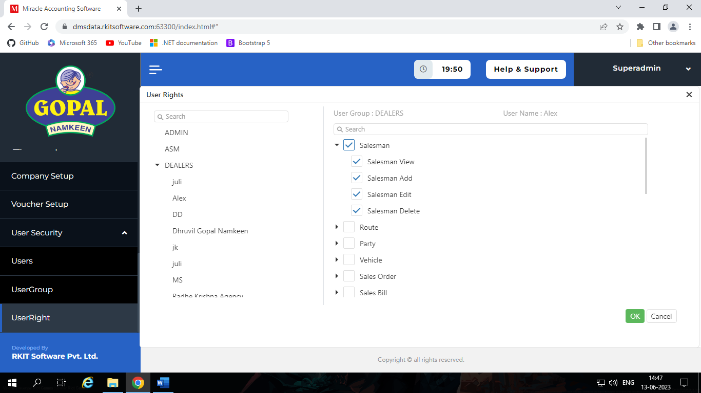

Company Setup
- In this section we can manage our different types of company setup.
- In this section we have four main setups.
  - General Setup
  - Advanced Setup
  - Master Setup
  - GST Setup
- These all setup we can do global level, dealer level or salesman level.

General Setup
- In this section we can manage general setup of company.
- In this section we have two types of setups.
  - Stock Setup
  - Mobile Application Setup
Stock Setup:
- In this section we have three setups.
  - Allow live stock
    - Highlight negative order in Sale Order.
  - Transaction Cancellation in Days
    - Ex: let say we can set 2 days
    - Then we can change means update or delete Sales Order until 2 days.
    - Today indicate 0, tomorrow 1 and then day is respectively 2, …
  - Allow Half Strip
    - It allows to dealer sales half strip.
    - It is only for mobile app and update in sale order and sale invoice not in Add Order or Invoice from warehouse.
Mobile Application Setup:
- In this section we have seven types of setup.
  - Last Publish Version
    - We can specify last version of Application
    - It is used for force update of mobile app.
  - Update Stock Before Continue Order
    - If No then, stock manage offline level in salesman app, don’t see effect in stock of any dealer purchase and other salesman punch order.
    - Don’t increase stock on dealer purchase and don’t decrease stock on other salesman punch order.
    - If they want effect in stock then they want to go online and click on “Get Current Stock”.
    - But if Yes, then when salesmen click on “Continuous” at that time all stock is sync from dealer stock.
  - Day Wise Route Display
    - It enables day wise routes
  - Write Error Log
    - One log file creates in mobile which contains log of salesman app.
  - Prevent Negative Order from Mobile
    - If it enables the salesman can’t do negative order for mobile
  - Prevent Order from Party List
    - If No then, It allows salesman to punch order direct from party list in mobile.
    - It doesn’t matter party is in none, lock, selling or in stock state.
    - But when we do Yes, then party must in stand by state, means it is in lock, selling or in stock state then and only the we can punch order.
    - Party must not in None state.
  - Salesman Tracking
    - If it enables then in mobile app one option add which id “Start Route”.
    - Then before salesman any route starts to visit the must click on “Start Route” and then they must complete that route and then they visit another route.
    - If they want to start visit other route before complete which they start before the they want to end route and give reason on why end route before complete.
    - But if it is disabled then salesman can visit multiple routes parallelly.

Advance Setup
- In this section we have two types of setup.
  - Advance Vouchers
  - Advance Options
Advance Vouchers:
- In this setup we have two options, which is,
  - QR Code Allow
    - It enables payment QR code in sales invoice.
  - Physical Voucher Required
    - It enables Physical Voucher option in dealer portal.
Advance Voucher:
- In this set up we have two options, which is,
  - Allow Negative Bill Generate
    - It allows dealer to generate bill also when stock is going in negative.
    - But it also gives warning.
  - Stock Days
    - It gives effect in Report section of “Current Stock with detail”.
    - Ex: Today’s date is 7 then our opening stock is closing stock of 6th
    - But if we set 2 in Stock Days then we get opening stock of 7th is two day before, means 4th closing stock is 7th opening stock.

Master Setup
- In this section we have three types of setup.
  - Decimal Point for Rate
    - We can specify decimal point in Rate of Product
  - Decimal Point for Amount
    - We can specify decimal point in Amount of Invoice
  - Decimal Point for Quantity
    - We can specify decimal point in Quantity of Product.

GST Setup
- In this section we have two of setup.
  - HSN Code Type
    - In this section we can specify HSN Code Type which we want use in DMS.
    - It has four option, which is,
      - Heading
      - Sub Heading
      - Tariff Heading
      - Chapter Heading
  - Decimal Point for GST %
    - We can specify decimal point in GST percentage.

Voucher Setup(Pending)

Master(Dealer)

Introduction
- In this section we have eight types of different component which is,
  - Product
  - Salesman
  - Route
  - Party
  - Sync mobile
  - Transport
  - Change Party Name

Product Master
- In this section we can see that which are the product we have assign by supper admin to sale.
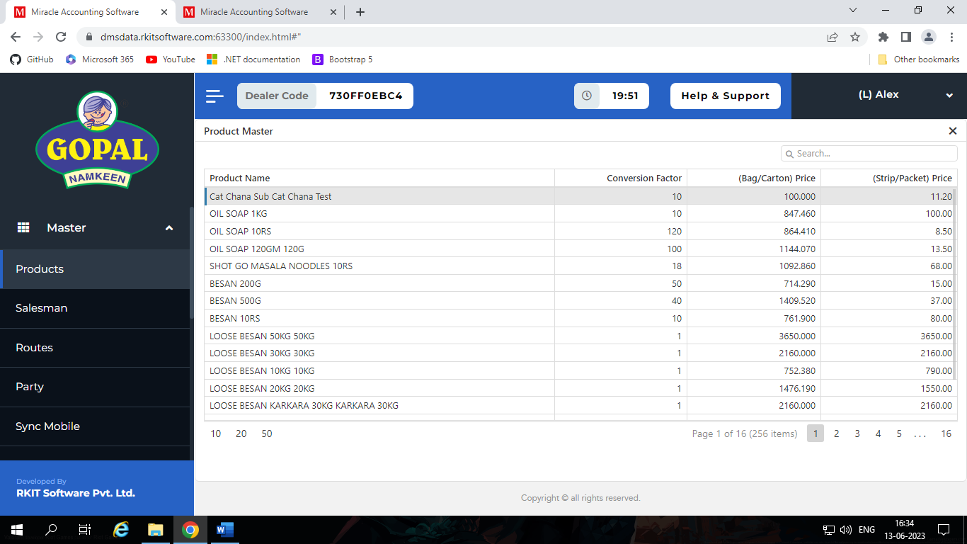

Salesman Master
- In this section we can manage salesman.
- When salesman registered from mobile app at that time, we can see here their details and we can change login states.
- We have three types of login states,
  - Approved
    - When we approved login state after salesman can logged in in application.
  - Pending
    - This state is by default when salesman registered in mobile app.
  - Suspend
    - It is used when we want to suspend salesman.
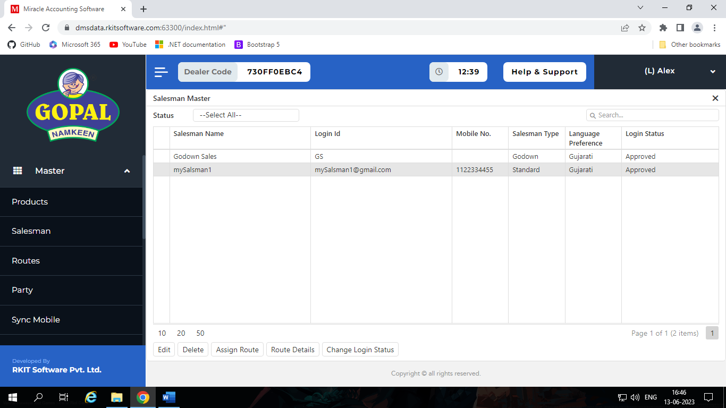
- We also can assign routes and see their routes details.

Route Master
- In this section we manage different route where our retails exist.
- We can view parties of route.
- We also can assign days of route; it helps use to show route to salesman on particular day not show whole week.
- In add-edit we have different options like,
  - Route Name
  - Description
  - Status
    - Active / De - Active
      - If we de-active any route then we can’t show that route in dealer portal and also all the party of exist in that route those parties can’t show, it doesn’t matter party is active or de-active.
      - But we can see those parties and route in Admin portal and change route status, Admin have four options,
        - Active
        - De-active
        - Suspend
        - Remove
  - Is Synced in Mobile App
    - If yes, the it will sync with mobile app.

Party Master
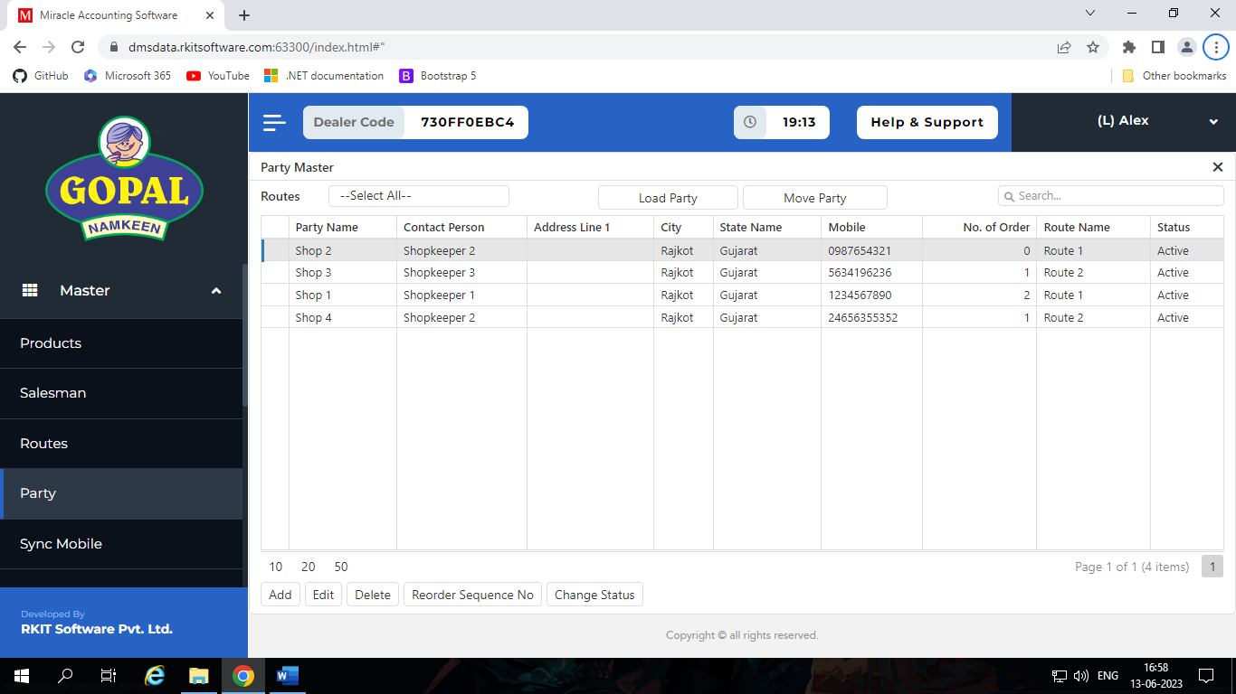
- In this section we can manage different parties of our dealer, in other world we manage our retailer shops.

- In add-edit we have different types of fields like,
  - Party Name
  - Contact Person
  - Address Line 1, 2 and 3
  - Pin Code
  - City
  - State
  - Gujarat
  - Mobile No
  - Registration Type
    - Regular
    - Consumer
    - Unregistered
    - Composition
  - GSTIN No
    - If we select regular registration type
  - Food License No
  - Status
    - Active / De – Active
    - Active / De - Active
      - If we de-active any party then we can’t show that part in dealer portal.
      - But we can see those parties in Admin portal and change party status, Admin have four options,
        - Active
        - De-active
        - Suspend
        - Remove

  - Shop Open Time
  - Shop Close Time
  - Route
    - This party exists in which route
  - Sequence No.
    - It is used to provide sequence shop, so salesman can know that which order of turn of shop they want to follow.

Sync Mobile(Pending)

Transport
- In this section we can manage our transporter.
- It has two filed Transporter Name and GSTIN which is 15 digit transport id provides by GST.
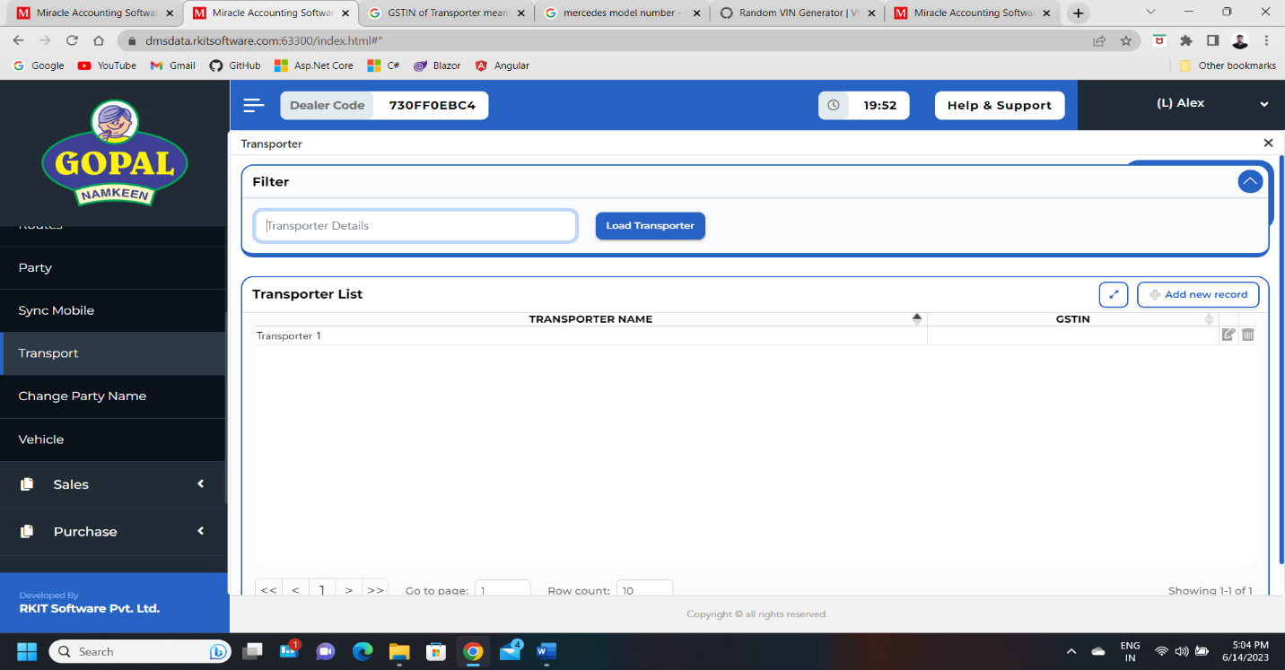
- This transporter we should use in sale invoice at the time of creation of e-invoice.

Change Party Name
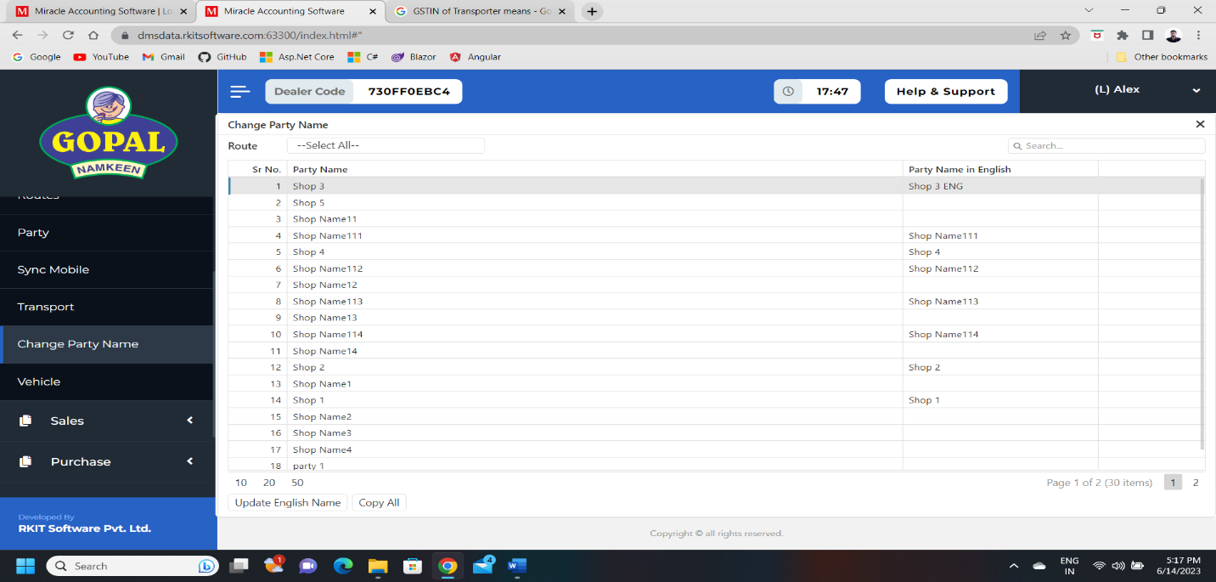
- In this section we can change their English name.
- If we want to set all the parties English name same as parties name then we don’t need to update one by one, we just click Copy All.

Vehicle
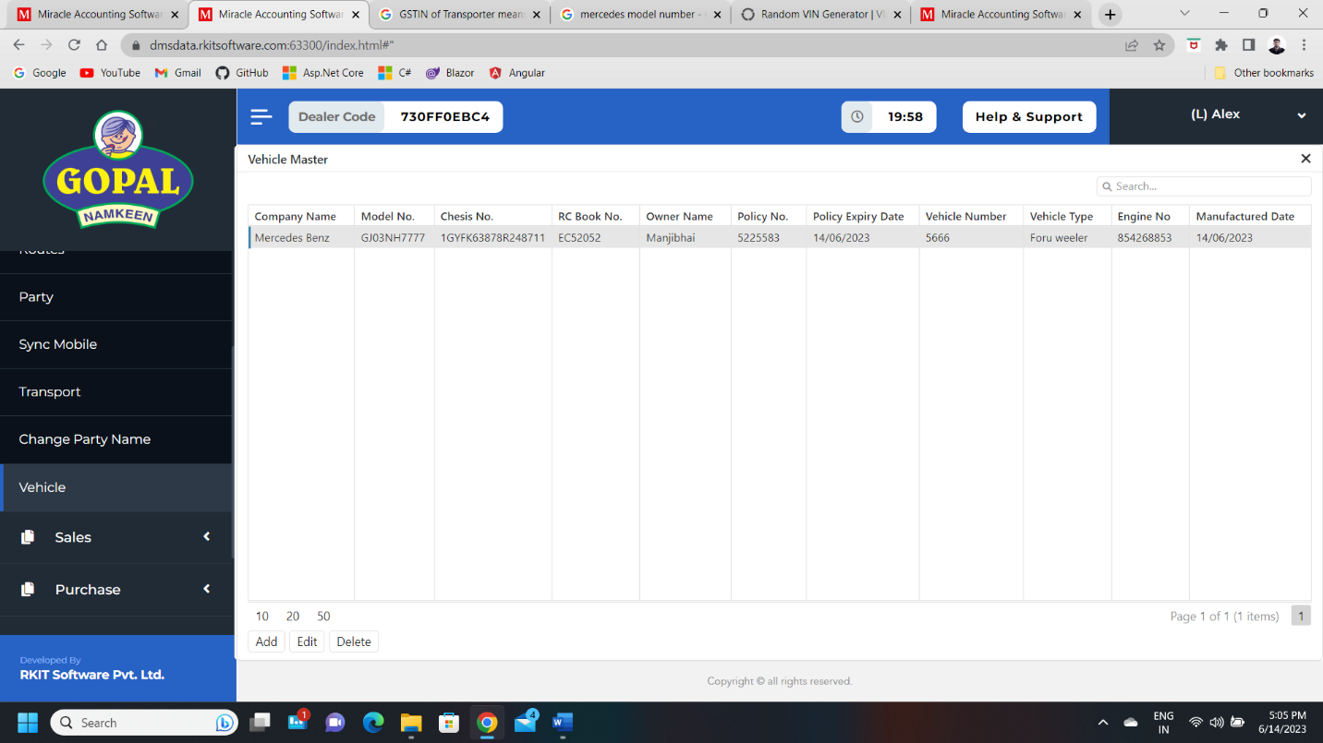
- In this section we can manage our vehicle’s detail.

Purchas(Dealer)

Introduction
- In this section we have three types of components which is,
  - Add Purchas Bill
  - Purchas Bill
  - Return Purchase

Add Purchase Bill
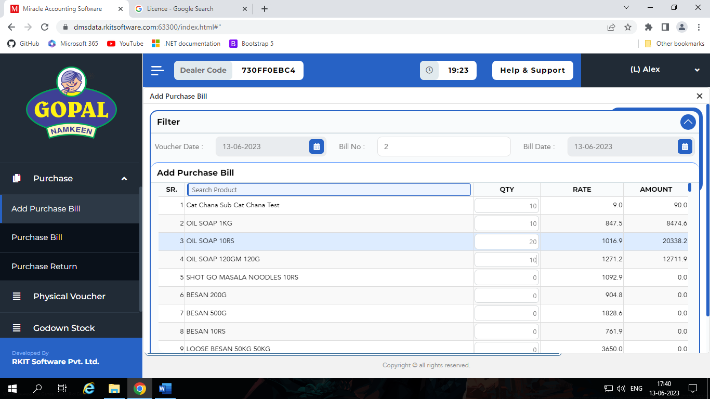
- In this section we can order stock of products.

- After we order something it’s order bill is show in Purchase Bill section.
- All Rate of Product is show which we earlier set purchase rate and sales rate at creation of product time.

Purchase Bill
- In this section we have bill of orders.
- By default, all Bill status is Pending, when our order is delivered by company at that time we should approve purchase bill and after approve purchase bill, our stock is increased as per order item.
- Stock don’t increase until we approve purchase bill.
- Second thing that we have is Bill Return, which is used to return particular stock.
- When we return some item for what evert reason at that time one entry add in Purchase return section and decrease stock from our inventory.
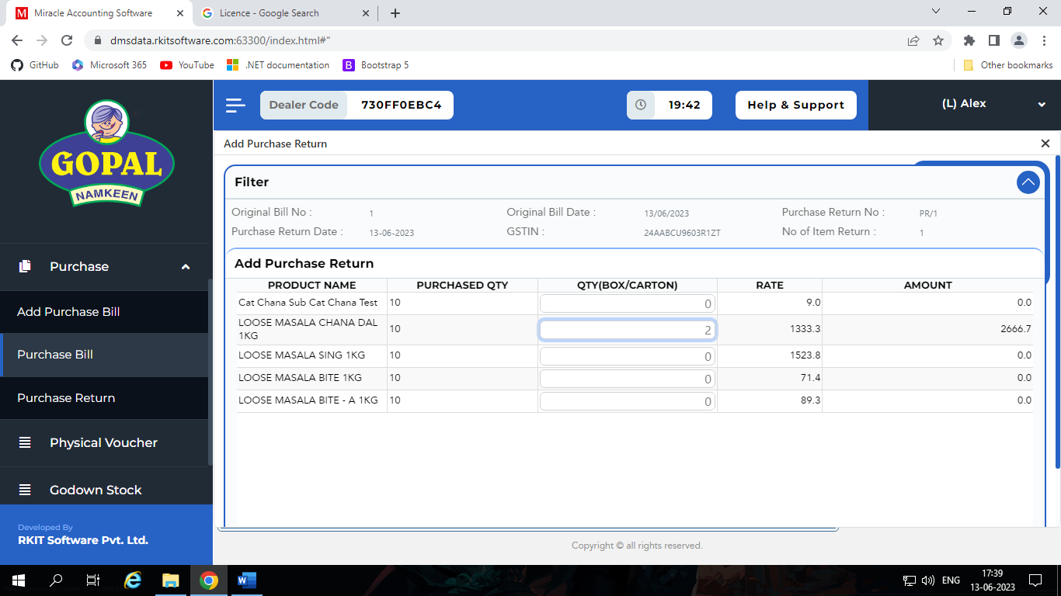
- Also, every order only can generate return bill only once.

Purchase Return
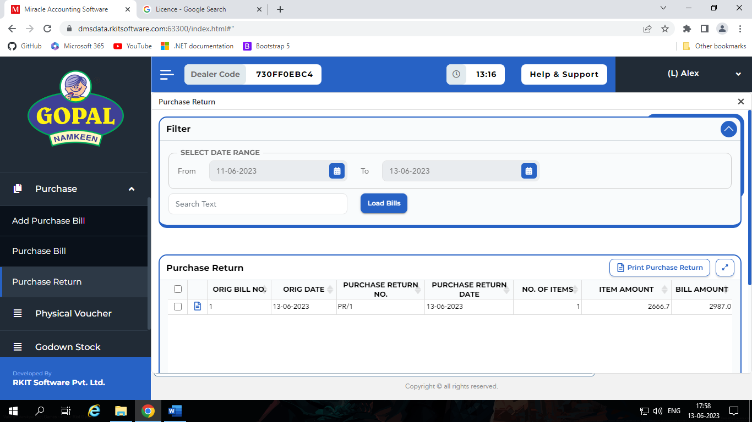
- In this section we can see all the purchase return bills.

Sales(Dealer)

Introduction
- In this section we have five different components, which is,
  - Add Sales Order
  - Sales Order
  - Add Sales Invoice
  - Sales Invoice
  - Sales Return

Add Sales Order
- In this section we can add new order from warehouse.
- In this order don’t involve any salesman, here all process taken by direct warehouse to retailer.
- After we save order, it’s record show in Sales Order section.
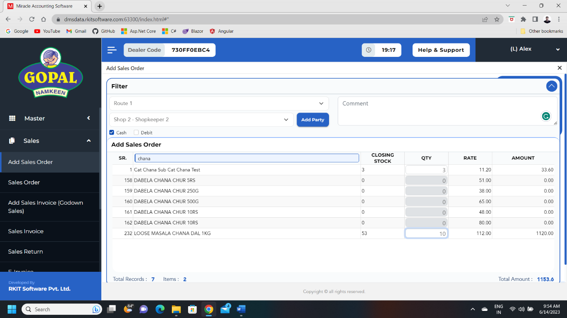
- After save order stock is decreased, but if we order from mobile by salesman the it don’t affect stock until we can’t generate bill.

Sales Order
- In this section we can see the order which is punch by salesman to visit parties and order taken by warehouse.
- In this section we can View summery, generate order form, remove negative order and generate bill.
- Negative order means salesman can take order of product over stock of product, so it become negative order, but salesman can do it if we can give rights to them.
- So this type of negative order we can remove.
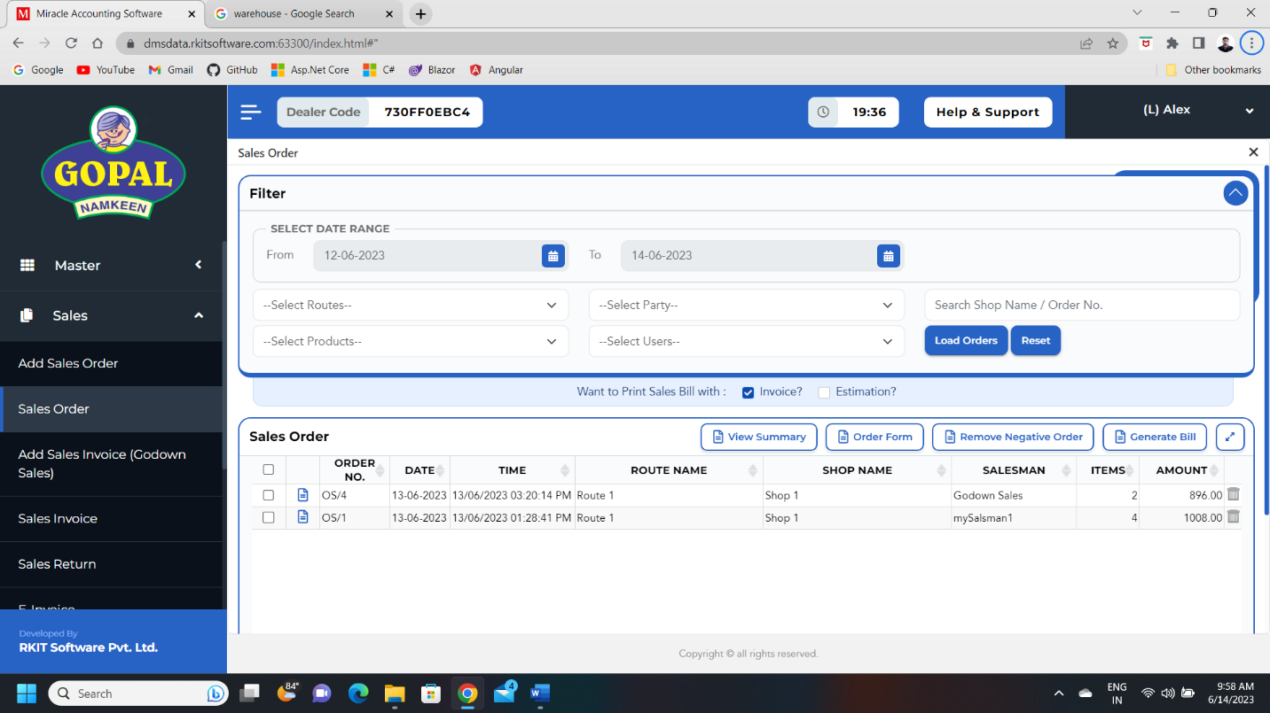
- When we delivered order successfully at that time, we should generate bill and after that recorded move from Sales Order section to Sales Invoice section.

Add Sales Invoice
- If we want to direct generate invoice without generate Sales Order from warehouse then we can generate invoice from this section.
- After generate invoice we can show it in Sales Invoice section.
- In this section we should choose party and route.
- We can specify mode of payment in cash or debit.
- We can specify comment on this order.
- We also have option to add new party.

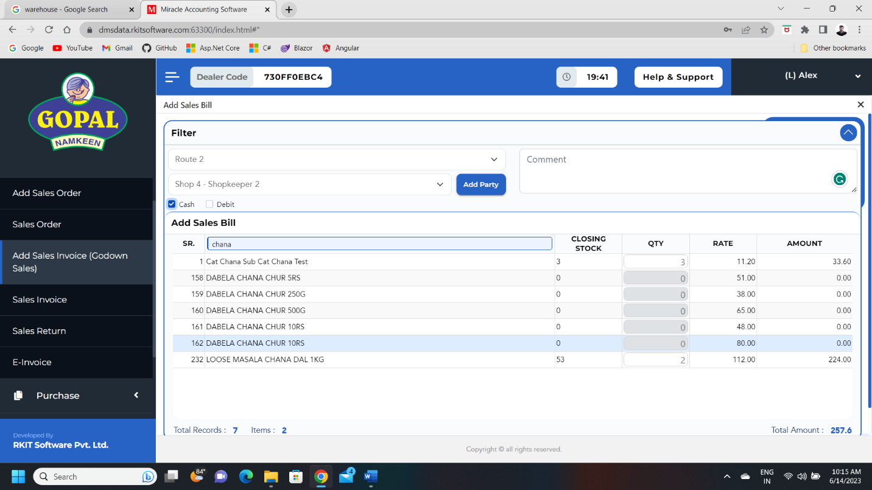

Sales Invoice
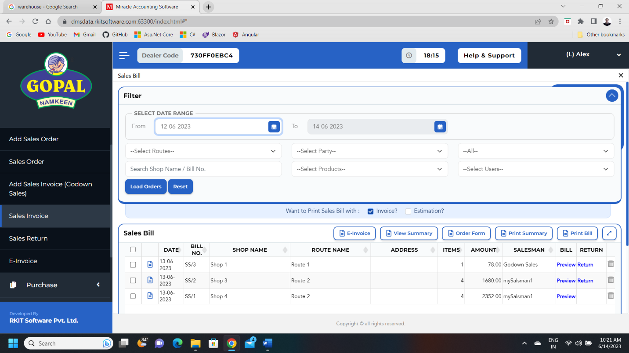
- In this section we can see all the invoice which we generate from Sales Order section and Add Sales Invoice.
- We print summary or return product.
- We can return product only once.
- After return option disabled.
- When we return some product at that time our stock is automatically increased.
- When we return Sales Invoice also that time automatically increased stock in our inventory.
- We can all the return product record in Sales Return Section.
- We have two check box which is invoice and estimation.
- If we select invoice the table title in in print bill is invoice.
- If we select estimation the table title in in print bill is estimation.
E-invoice:
- In this section we have options to generate e-invoice, so if we want to generate e-invoice the we can do, but we can only generate e-invoice for B2B transaction.
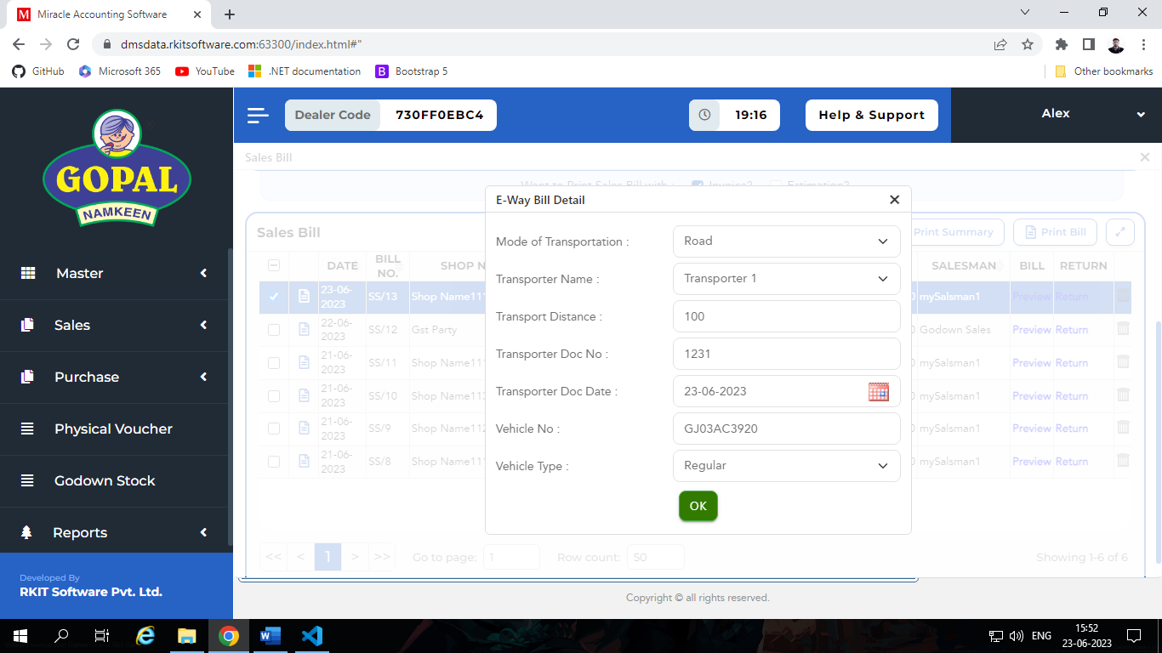
- So we can only generate e-invoice for those sale invoice which party type is Regular or Composite, because these type of parties have GST no.

- We have different field in form for generate e-invoice.

  - Mode of Transportation
    - Road / Rail / Air / Ship
  - Transporter Name
    - This options comes from transport master.
  - Transport Distance
  - Transporter Doc No
  - Transporter Doc Date
  - Vehicle No
  - Vehicle Type
    - Regular
      - It means normal vehicle which we use for transport like four-wheeler or normal truck.
    - ODC
      - It means those vehicle which is use for special transportation of goods which have all safety equipment.
- At the end when we submit form we get json to download which contains all information about transportation.
- These e-invoice records we can see in e-invoice section.
View Summary:
- In this section we can view summery of one or more invoice.
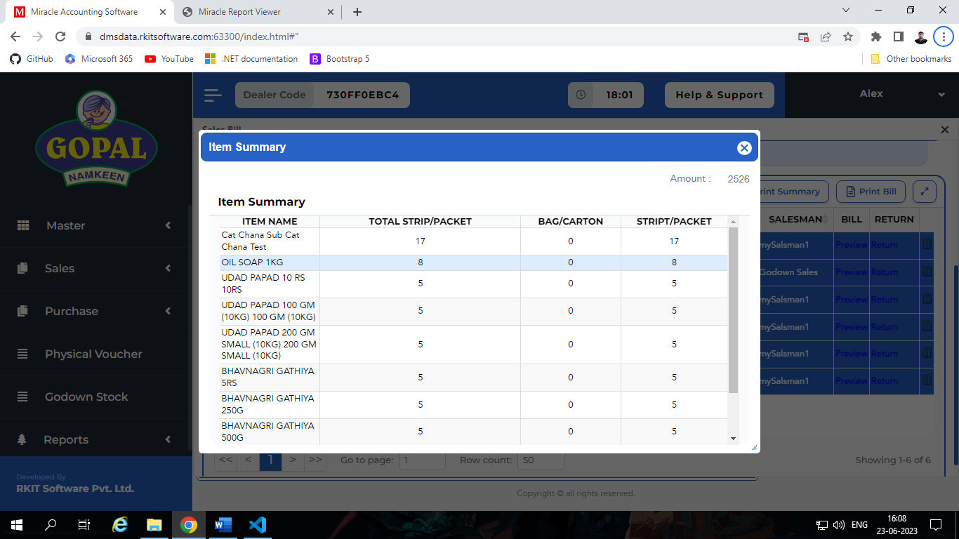
- It give’s product wise ordered carton/bag, packets/strip and total strip.
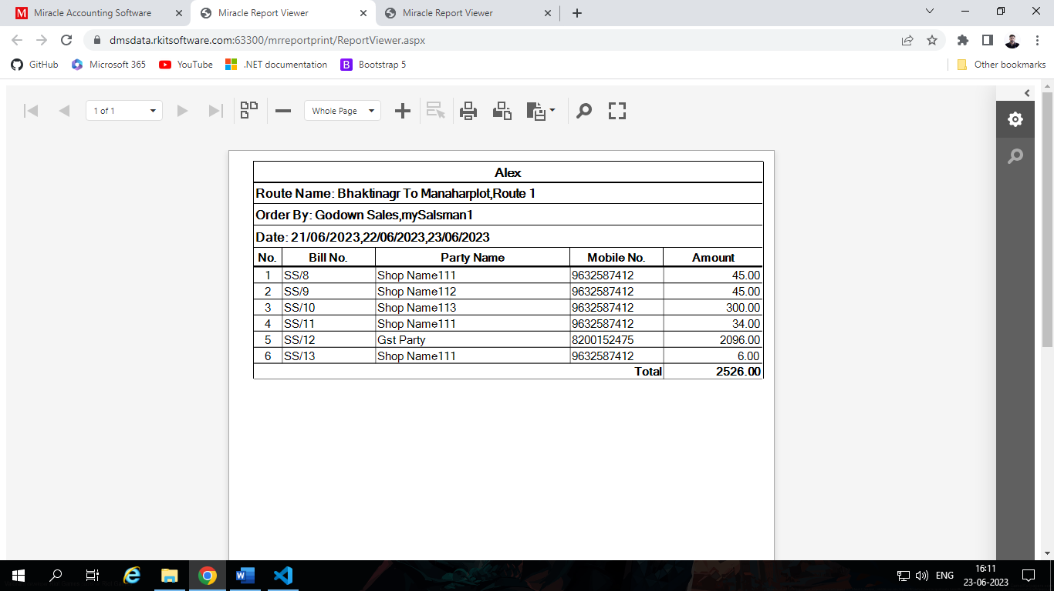
- We also print summary for which one or more invoice which is give use details of party name, invoice no, mobile no of party and total amount.

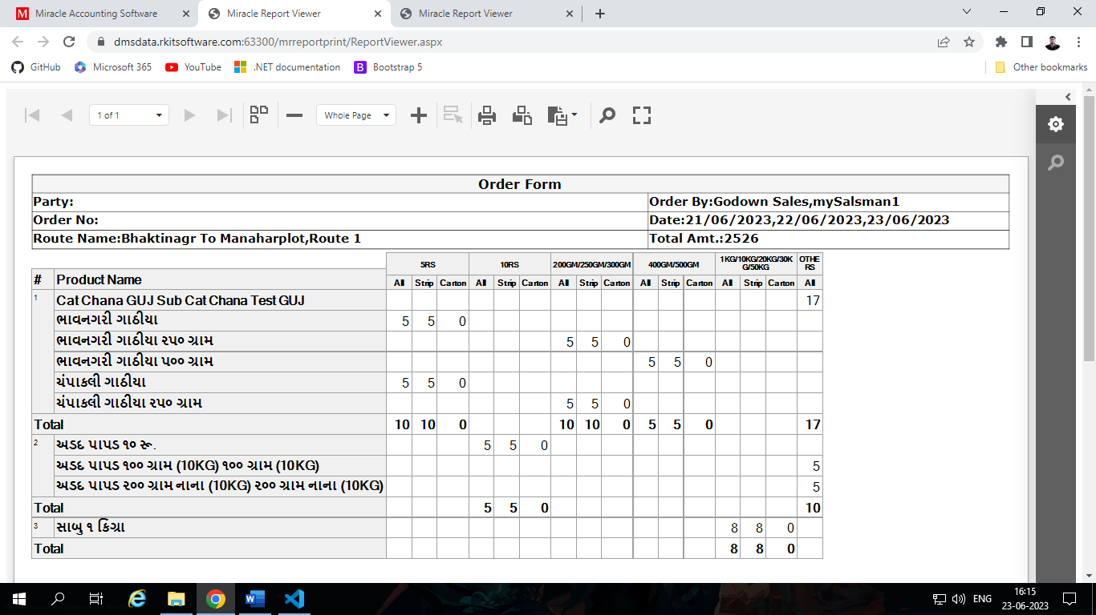
Order Form:
- We also can see the order form for one or more invoice which contains details of product and it’s carton/box, strip/packets and total strip sub category wise.

Sales Return
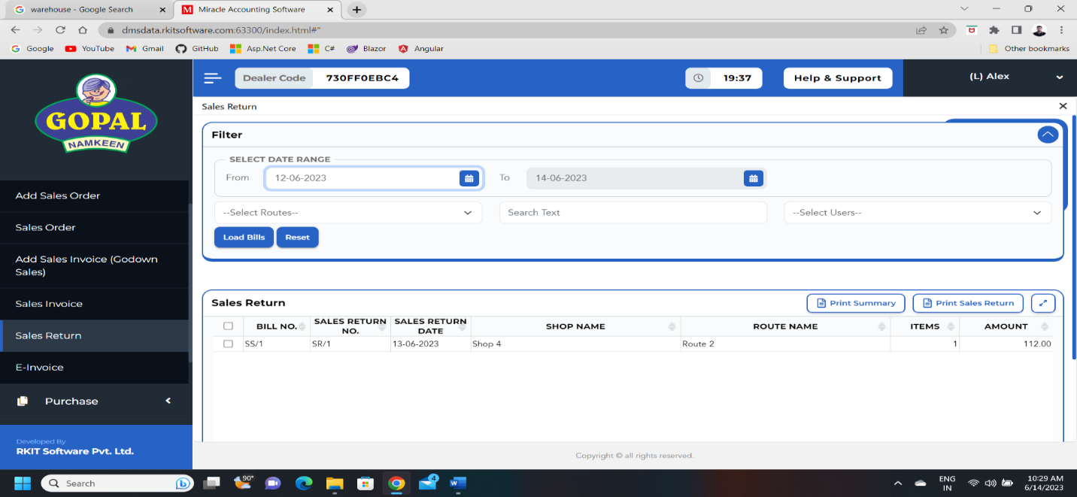
- In this section we can see return products record and generate print Sales Return.

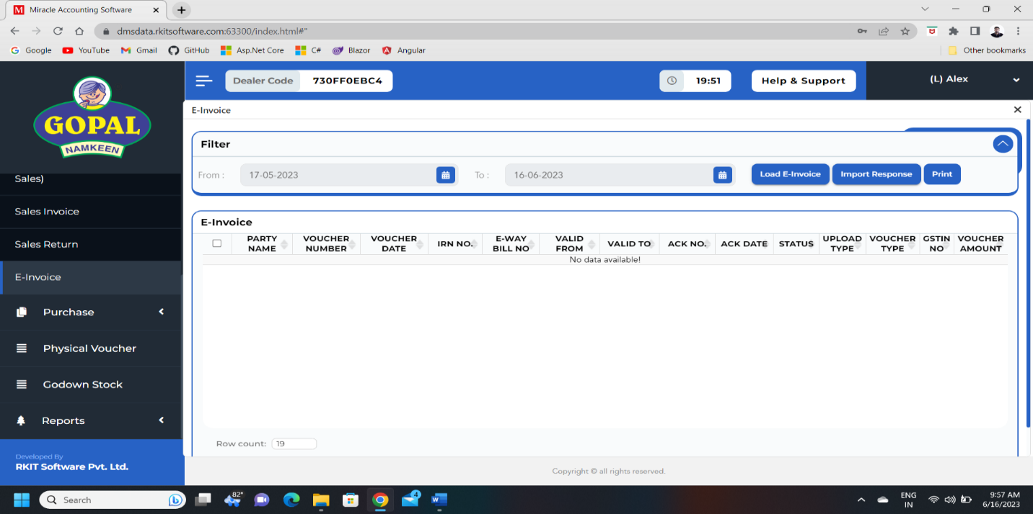
E-Invoice
- In this section we can manage our e-invoice records.
- We can upload e-invoice.
- E-invoice is generated by government on their portal for B-to-B transactions.
- So every dealer should generate it on government portal.
- So that type of invoice we can easily store in this section and manage it.

Physical Voucher(Dealer)

Introduction
- In this section we are manage physical voucher.
- Ex: we have 10 quantities of stock for A product on portal.
- But actual stock in warehouse is 4 quantities for some reason 6 quantity is missing.
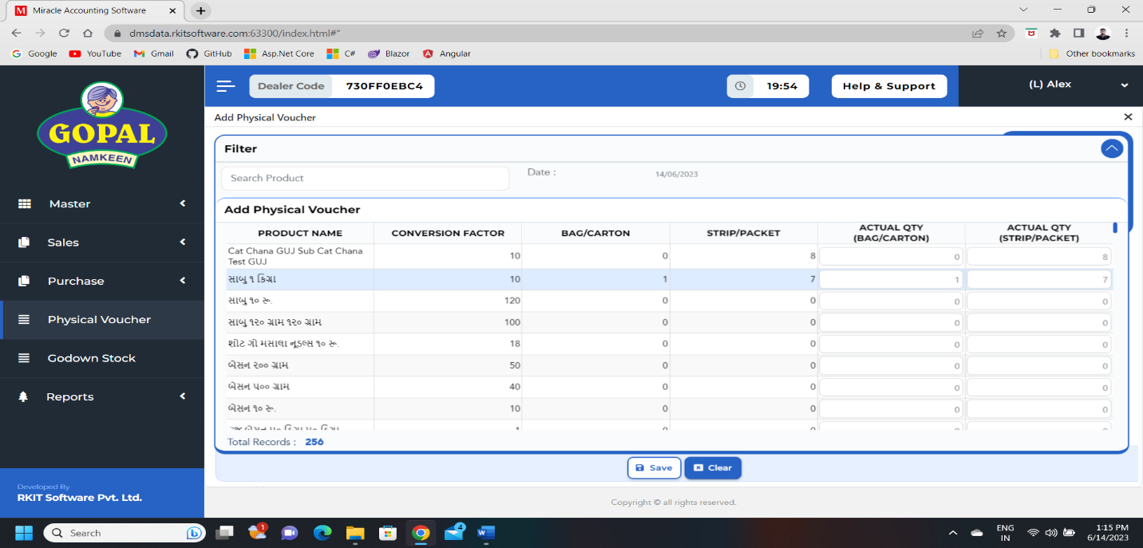
- So at that time we add physical voucher to increase or decrease stock of particular product.
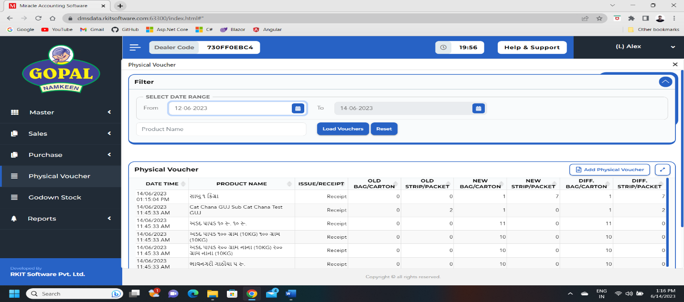

Godown Stock(Dealer)

Introduction
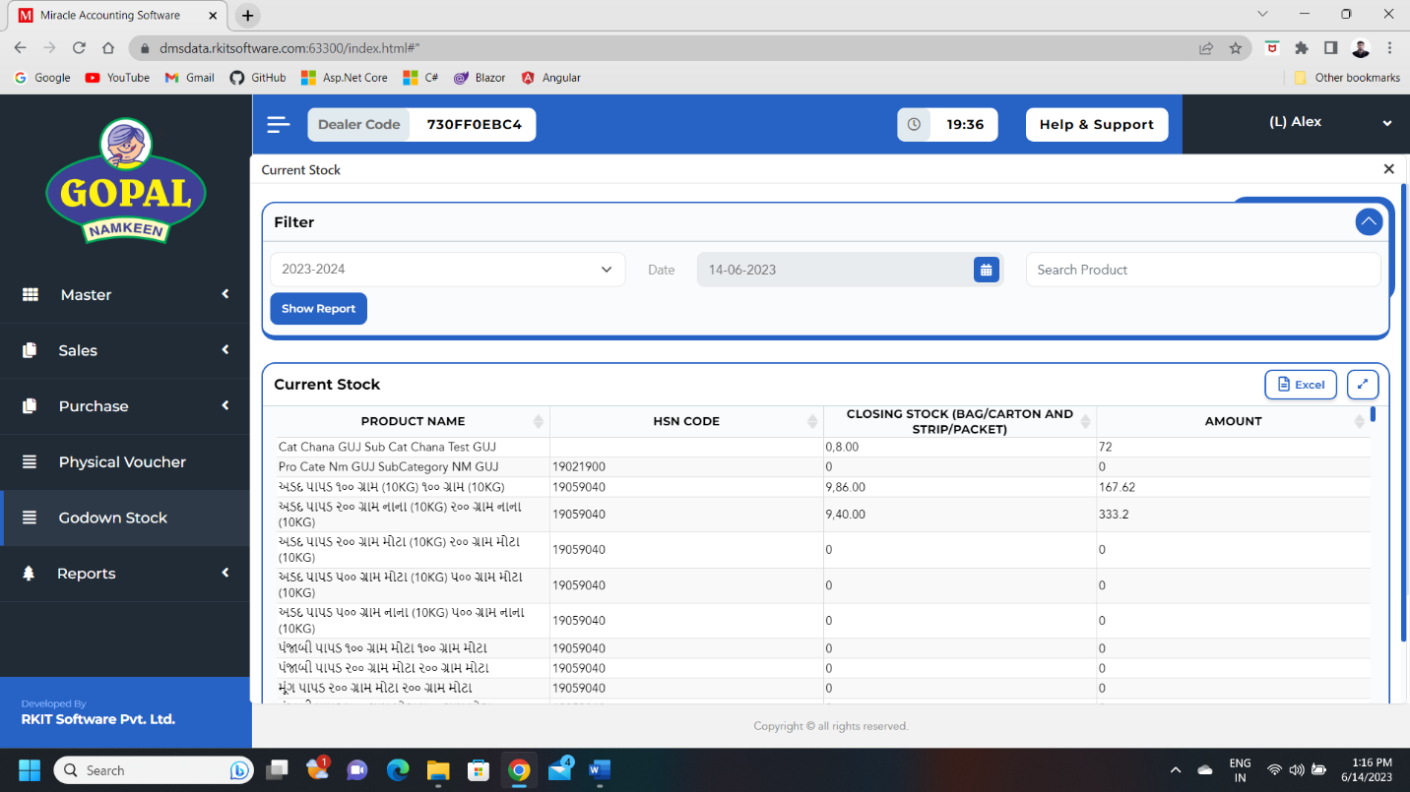
- In this section we can see how much stock we have in our warehouse.

Report(Dealer)

Introduction
- In this section we have multiple type reports like,
  - Sales Report
    - Sales Order
    - Sales Bill
    - Delete Order
    - Deleted Bill
    - Party Status
    - Sales Return
    - Sales Bill Register
    - Sales Order vs Bill Qty
  - Purchase Report
    - Purchase Bill
  - Summary Report
    - Total Summary
    - Salesman Summary
  - Stock Report
    - Current Stock with details
  - Analysis Report
    - Salesman Analysis
    - Daily Route Sales Status Analysis
- It is same as report of super admin, but some of report not give to dealer.
- Second thing is admin can see all the dealer of report so they have more filter options like State, District and Dealer…
- Where dealer can see only their reports, so dealer have not filter options like State, District and Dealer.
- One more change is Total summary of Superdmin and Dealer is different.
Total Summary:
- In this report we can see the details of date wise basic activities of dealer like,
  - Number of purchase and it’s amount
  - Number of sale order and sale bill and it’s amount.
  - Number of physical vouchers.
  - Number of sale return and it’s amount.
- It has different types of filters like,
  - Financial Year*
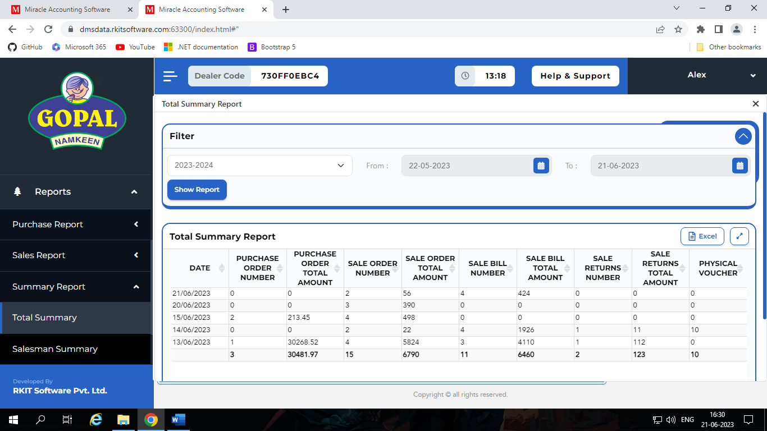
  - Range of Date*

Application Setup

Introduction
- This application is used by salesman to punch order of parties.
- First we have login scree for salesman, in this section sales man login with their details and dealer code.
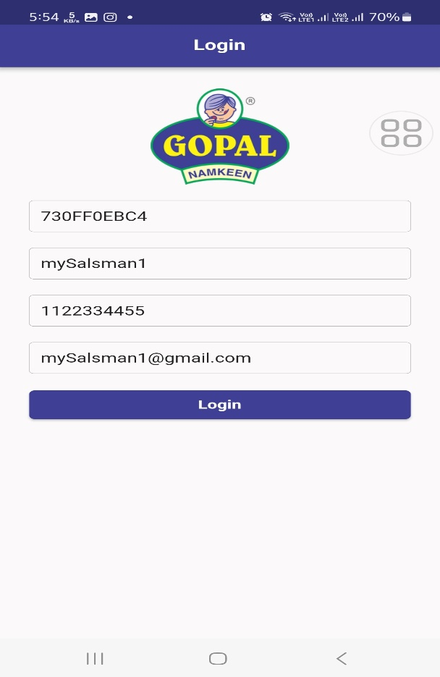
- After log in salesman successfully with dealer approval, salesman can see their home screen.
- In this screen we have order button to see different order details and manage order also we have date picker which helps use to see order datils of past order.
- We have options menu which contains three options,
  - About
  - Backup
  - Logout

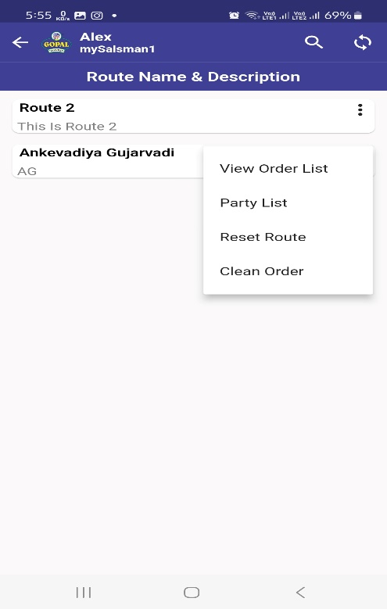
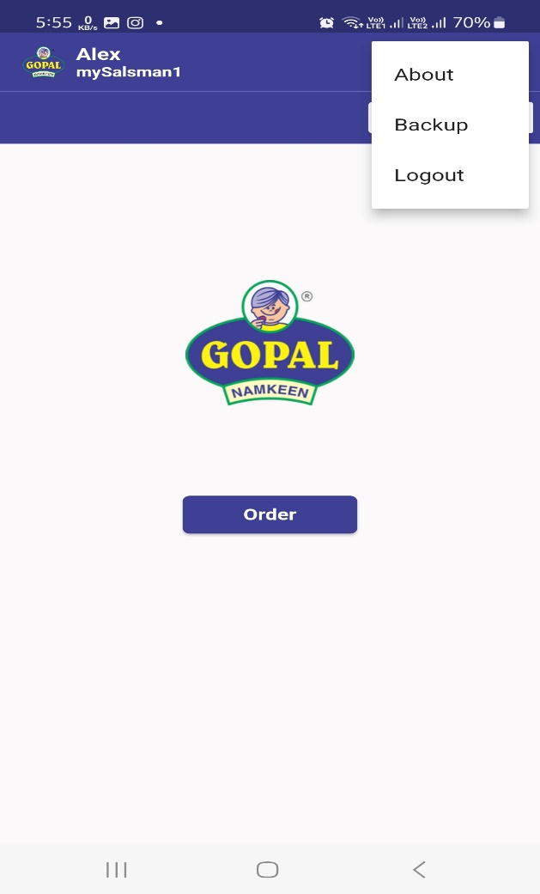
- When we click on order, we can see different routes.
- We have four options in route button.
  - View order list
    - We can see the order details of parties which exist on this route
  - Party list
    - We can see the list of parties which exist on this route
  - Reset Route
    - We can reset route and re-take order from first party from route.
  - Clean Order
    - We can clear all the order of parties which exist on this route.
- We can start route using click on Route name.
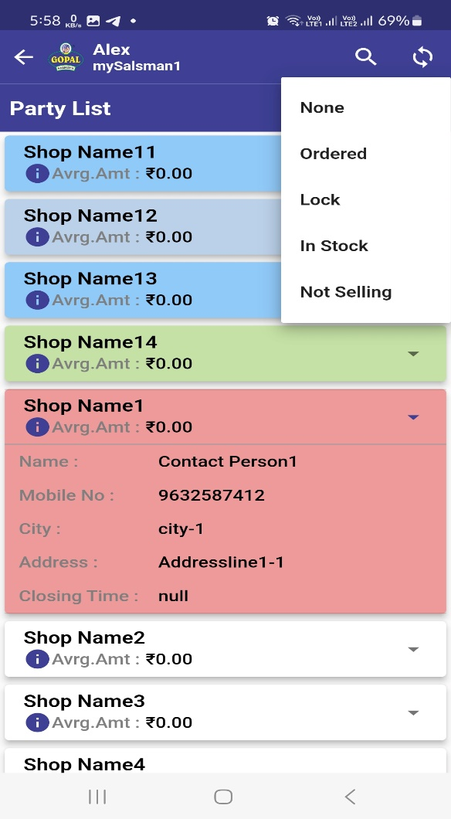
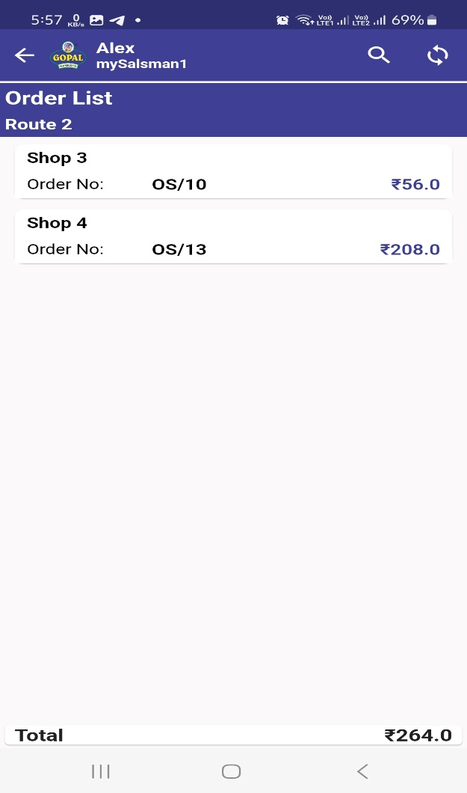

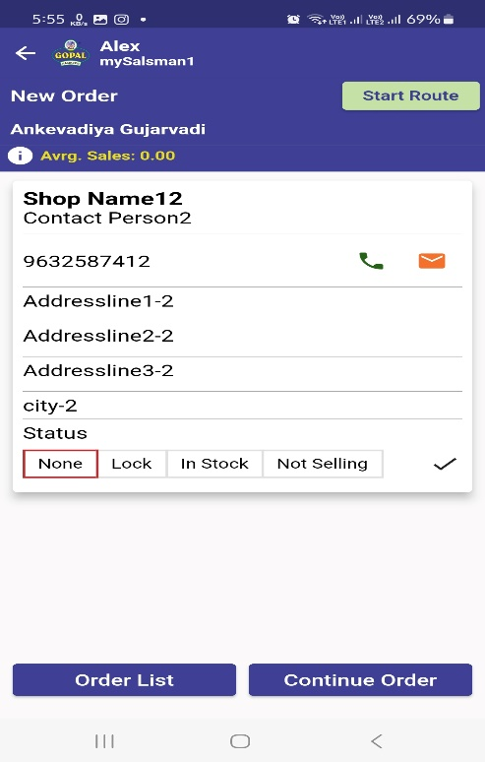
- Now when we click on route name, we have seen details of first party of this route.
- We can set their status in four ways,
  - None
  - Lock
  - In Stock
  - Not Selling
- We also have two button which is,
  - Order List
    - Show past order
  - Continue Order
    - Take new order

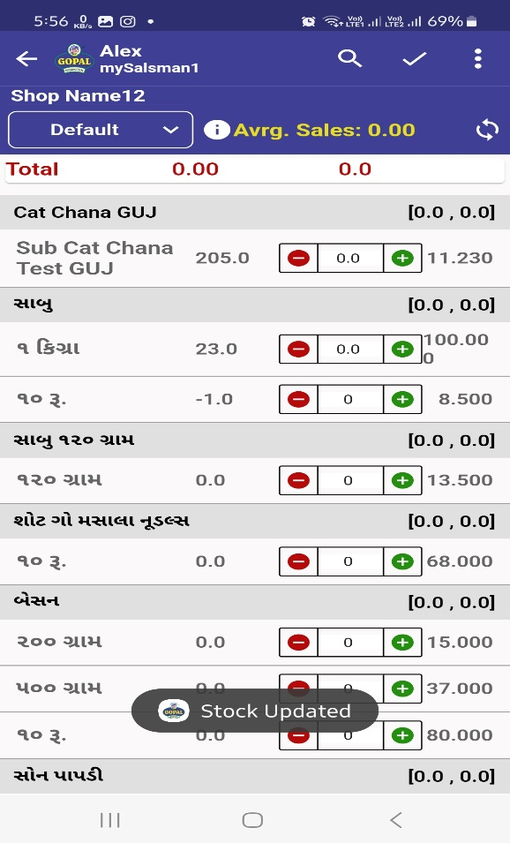
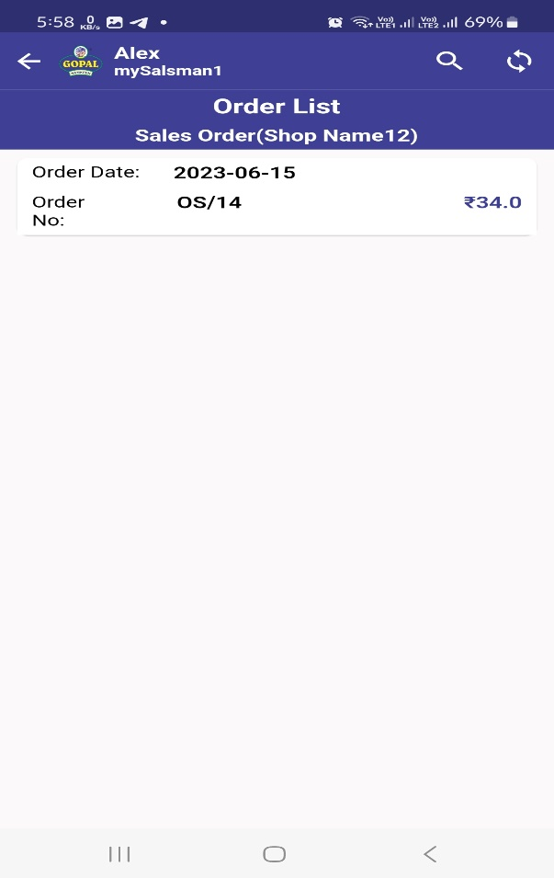

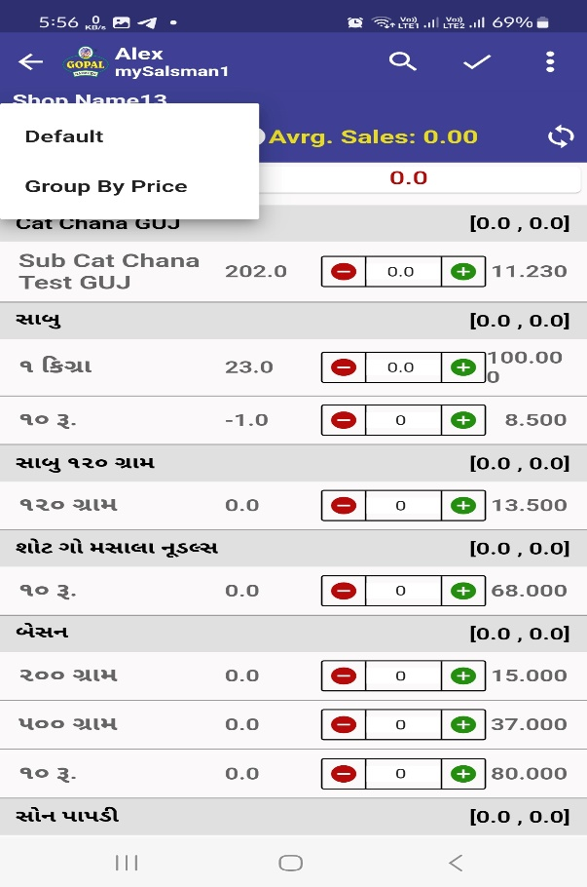
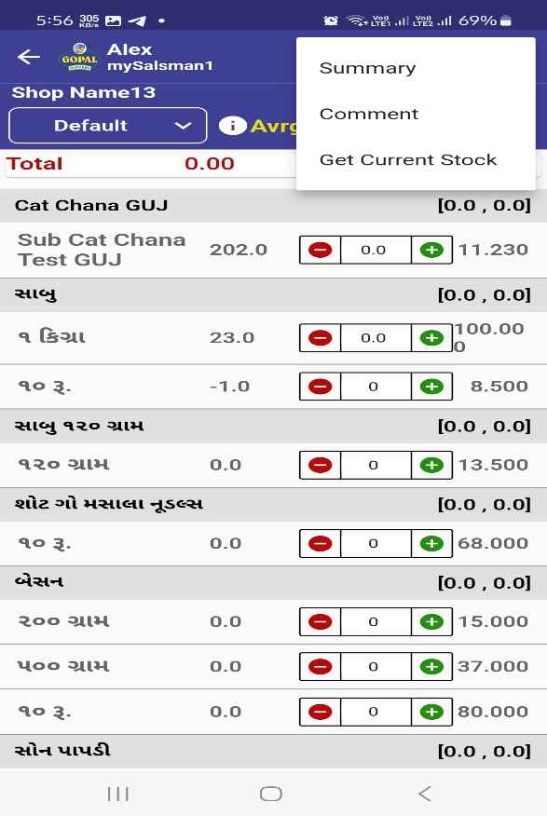

- We can manage order of product details which we can see on screen
  - Default
    - It orders on Product category and Sub Category
  - Group By Price
    - It orders on price of products.
- We also have options menu which contains three options,
  - Summary
    - In this section we can see the summery of order.
  - Comment
    - In this section we can add comment for this order
  - Get current stock
    - If we want to sync stock from the dealer stock the we can click on this option.
- We have also one search box which can helps us to fine appropriate product.
- At the end we should click on right button to save this order.
- After we save order, we can see the details of next party.

